# Phishing Unfolding

مختبرعملييعلّمكيفيةتتبعحملةتصيّدمنالبدايةإلىالنهايةداخلبيئةآمنة**.**

يشمل**:** مسحالخدمات،فحصصفحات **HTML/JS**،اعتراضالطلبات،وتحليلالملفاتالمرفقة**.**

الهدف**:** استخراجالأدلةوالأعلاموتوثيقخطواتالتحليلمعاقتراحاتوقائية**.**

الواجههالرئيسيةللابوتعرضالادواتوالتنبيهات**:**

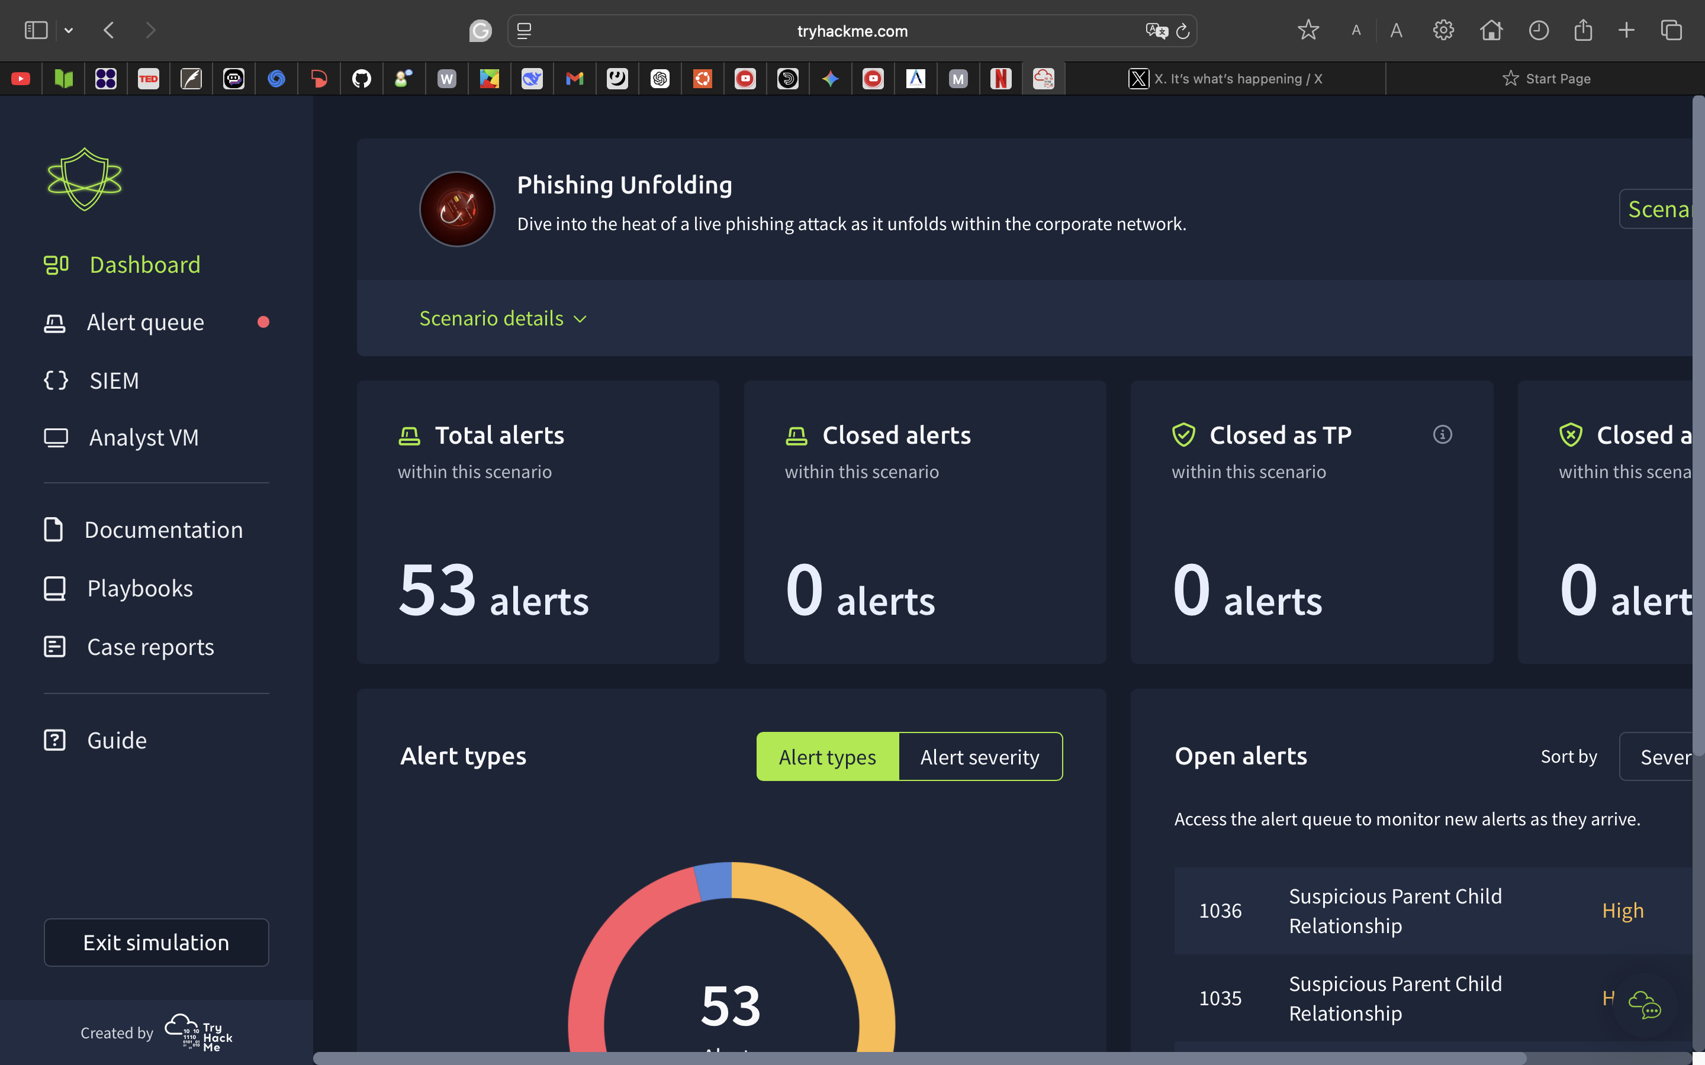

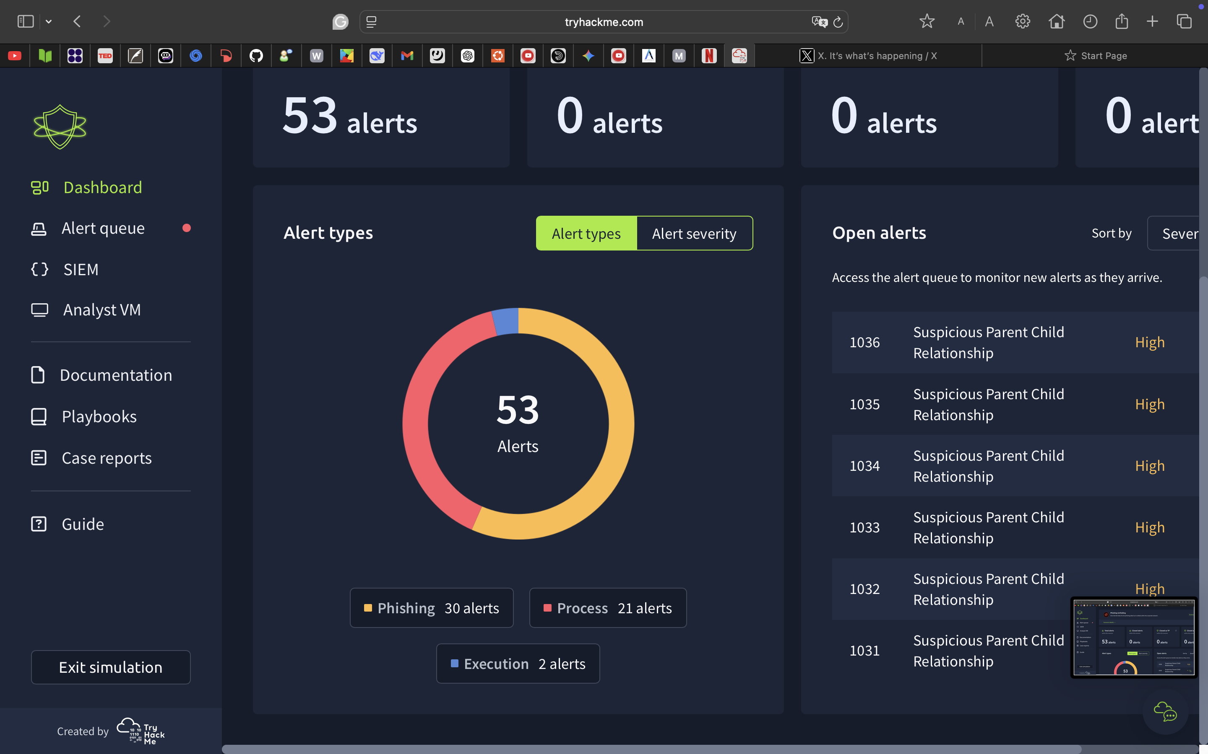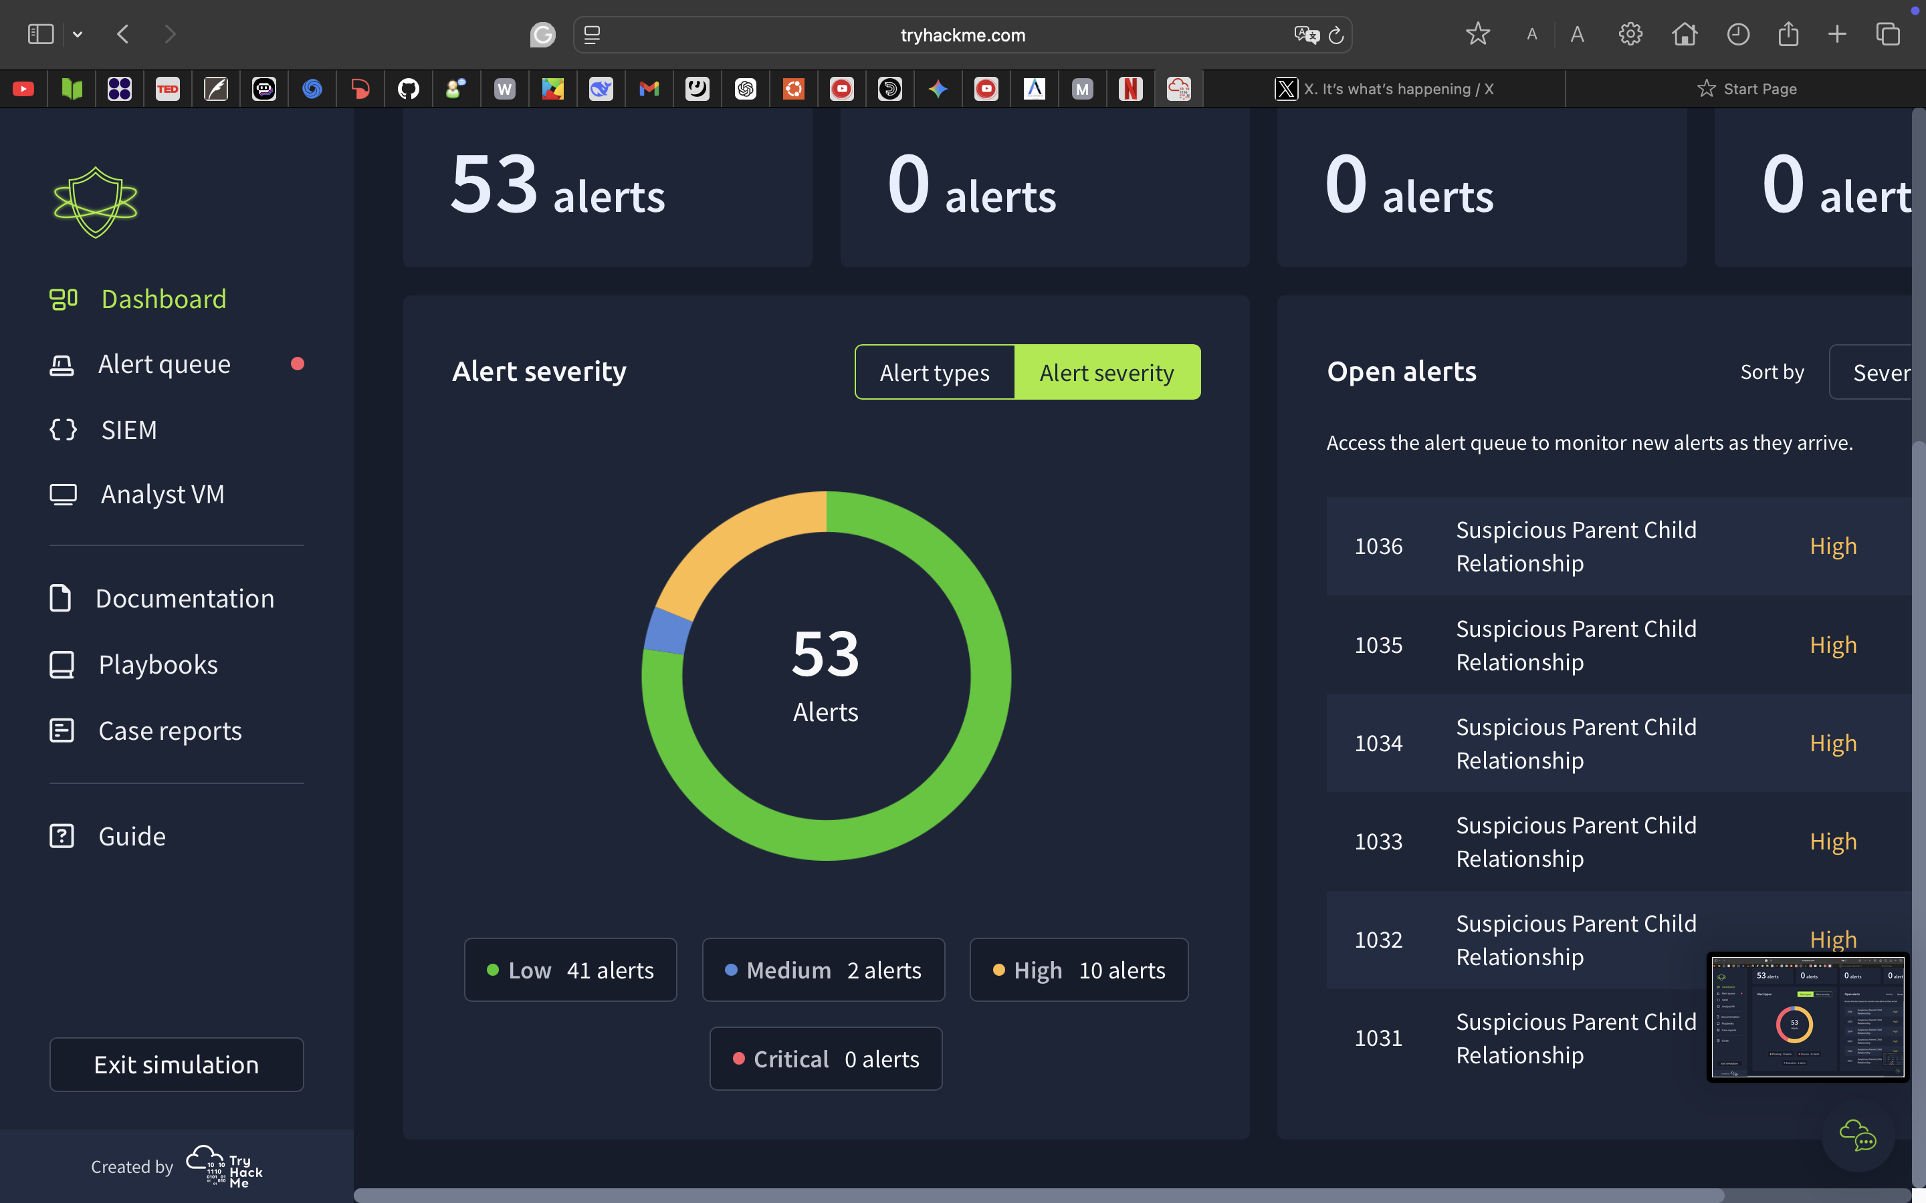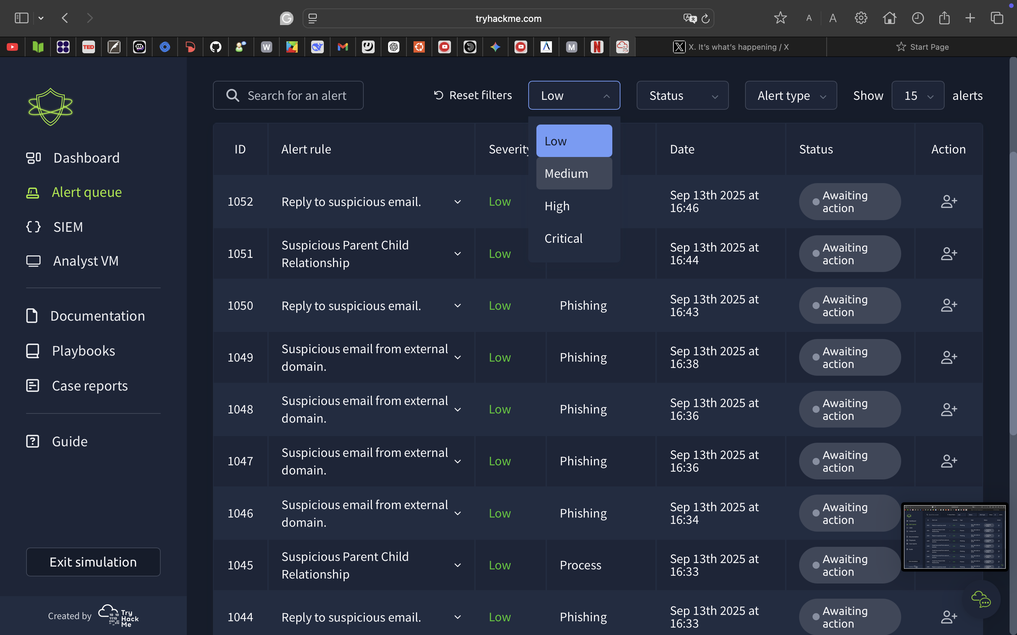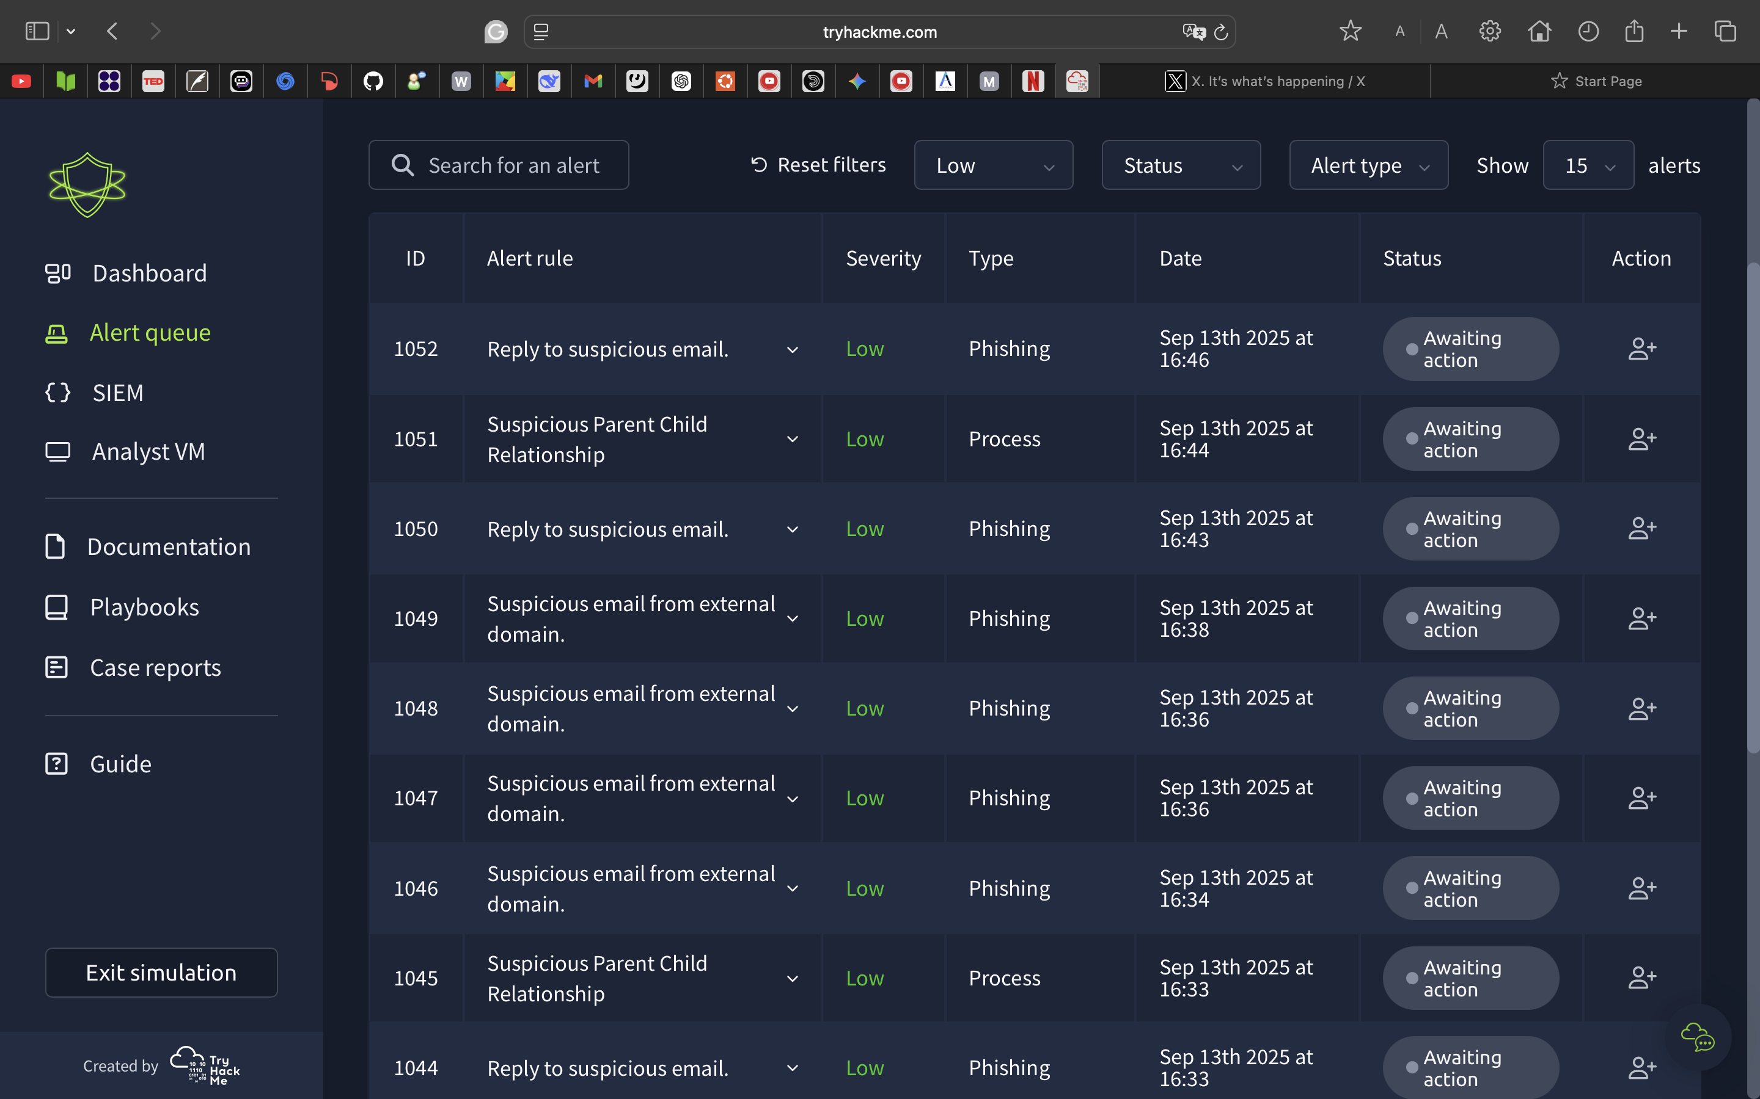

هنا التنبيهات وانواع خطورتها

هنا يعرض التنبيهات وسجلات الشبكه المشبوهه:

عندنا فلتر يعرض لك الهجمات حسب الخطورة:

١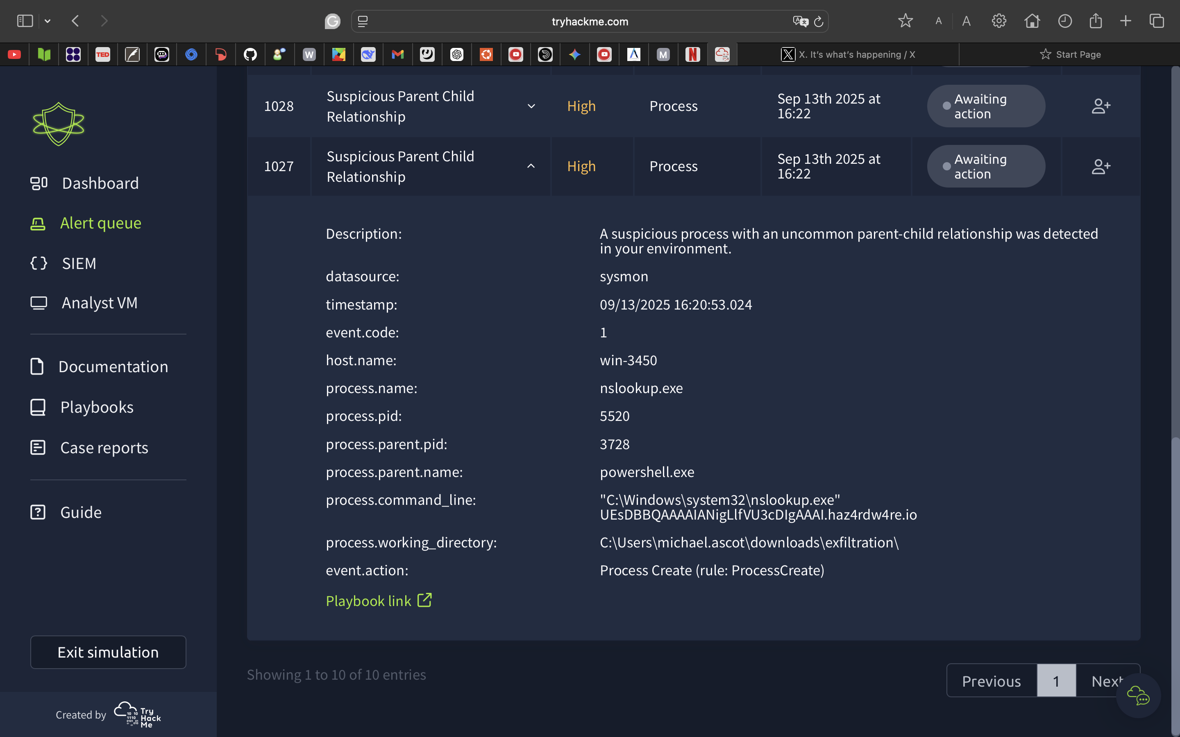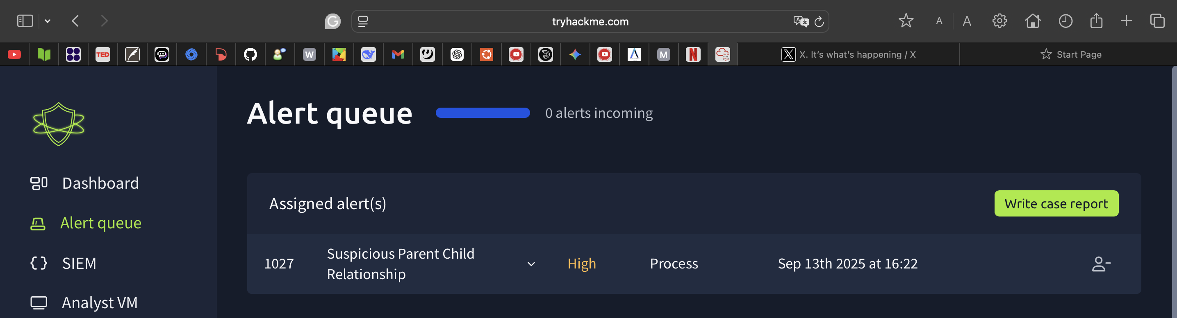

هنا تقدر تشوف كل المعلومات عن التنبيهه اللي تشك فيه وتبدآ تتعامل معاه وتتحقق منه :

تضغط هذي الايقونه عشان تبدأ تتعامل مع التنبيهه :

يظهر التنبيه هنا ويتم التعامل معاه وارسال تقرير :

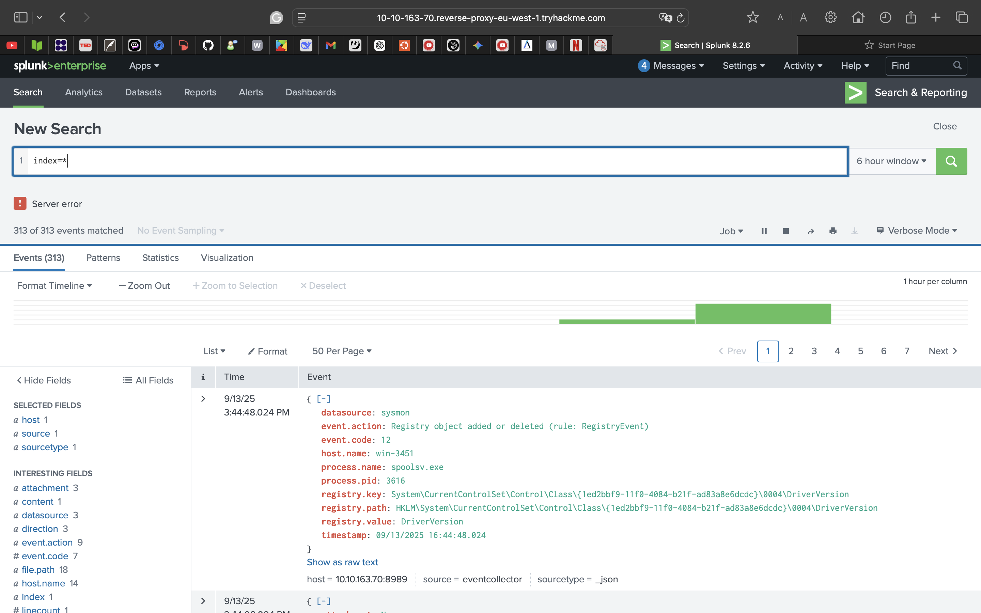

Caption

لكن قبل ما ابدأ اتعامل مع التنبيه وارسل تقرير لازم اتاكد هل التنبيه فعلا شي خطير ولا مجرد تنبيه بسيط ف ادخل للsplunk وابدأ اتحرى واتأكد :

خطوات التحقيق في أداة الsplunk :

بعدماتأكدناانهفعلاتهديدعلىالشبكةنرسلتقريروطبعابيكون **True positive**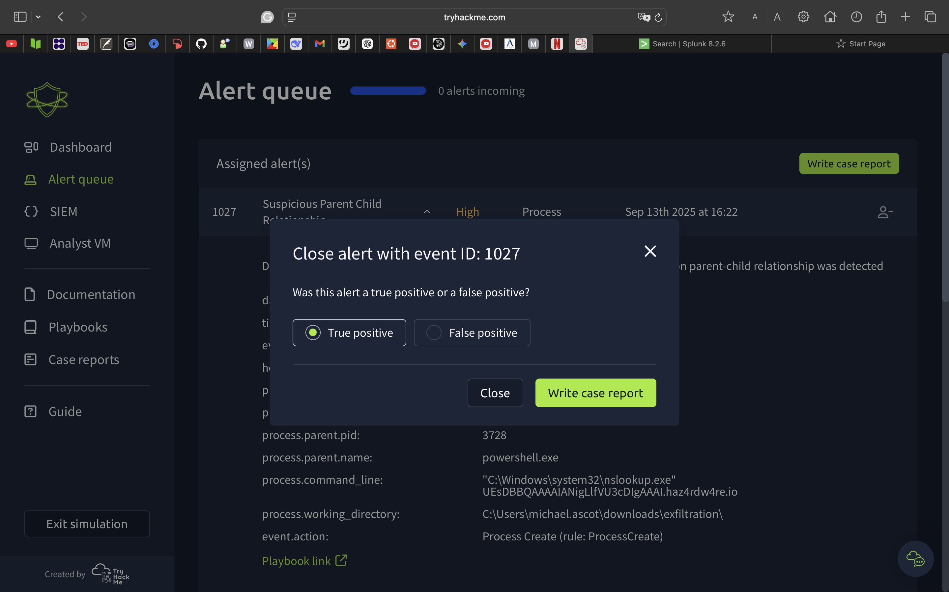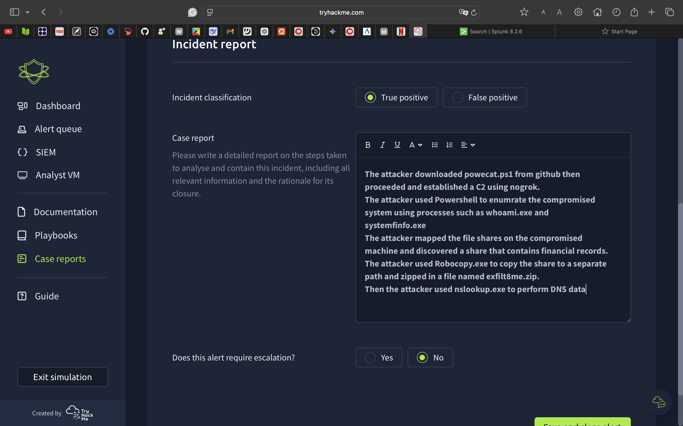

كتبت تقرير مفصل عن كل الخطوات ورفعته :

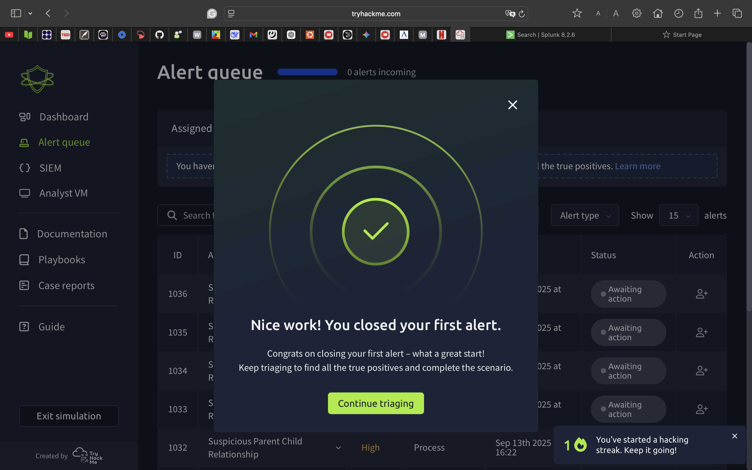

منهذيالقائمةتقدرتشوفكلالتقاريرالليرفعتهاوتعدلعليها **:**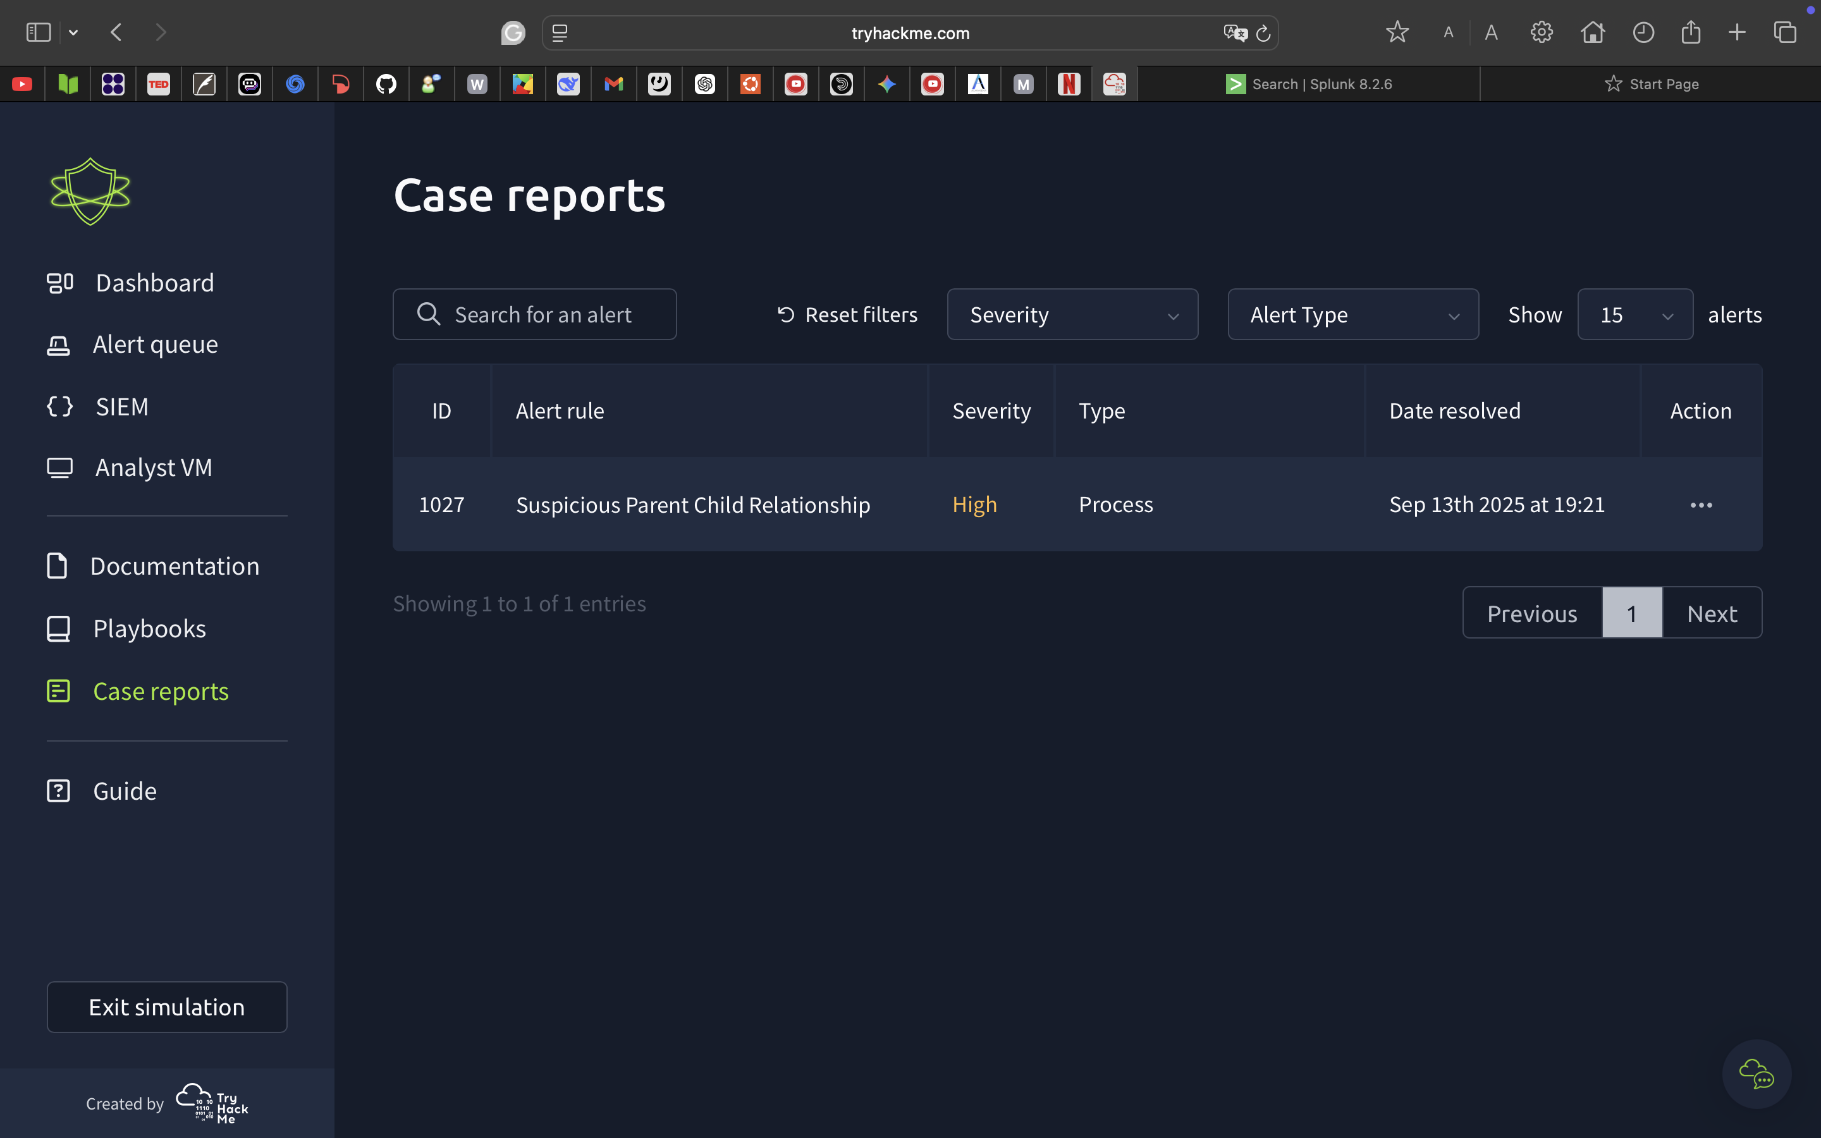

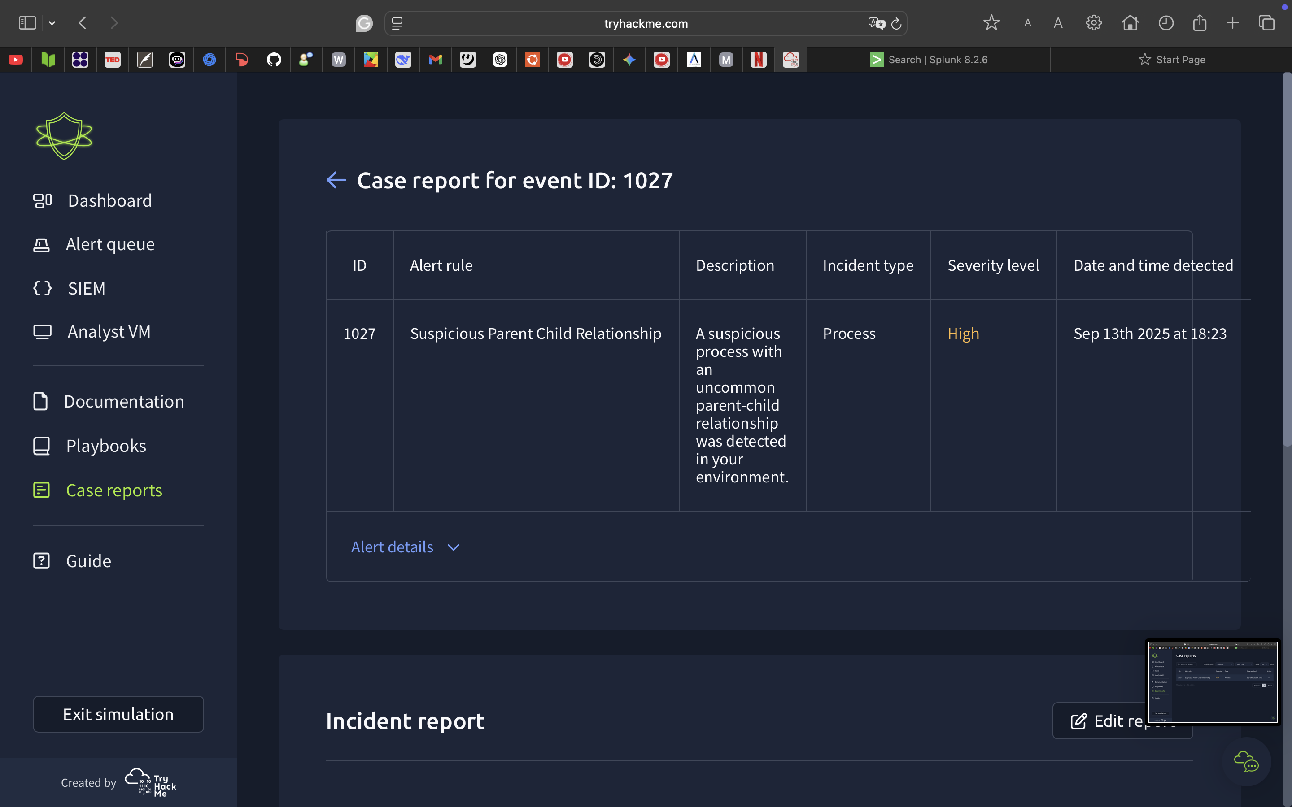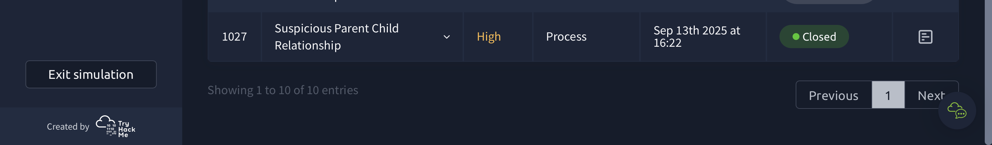

الان بعد ما تعاملنا مع التنبيه تشوف انه تقفل:

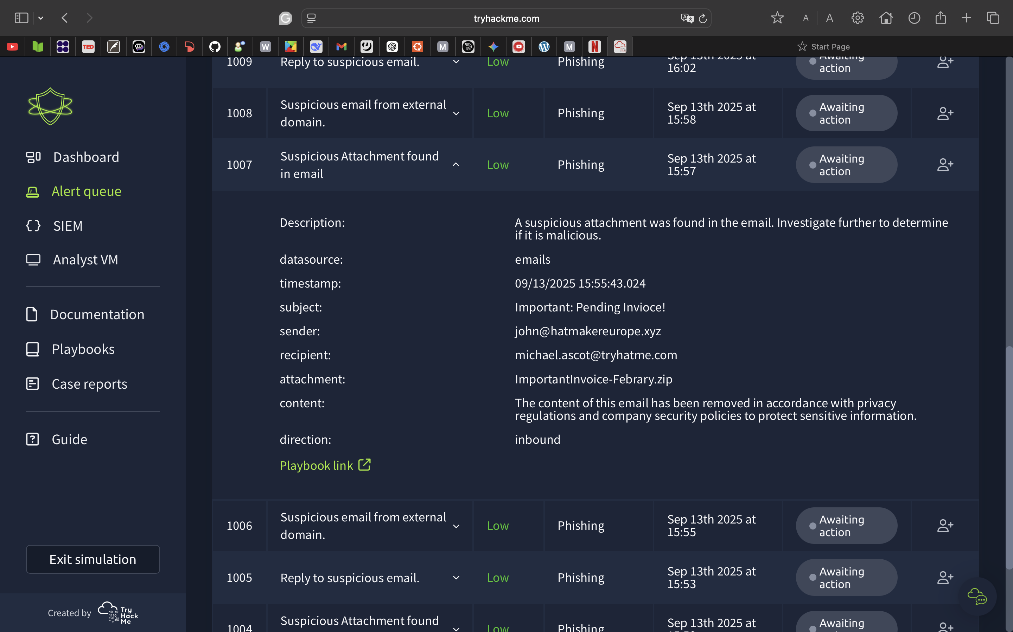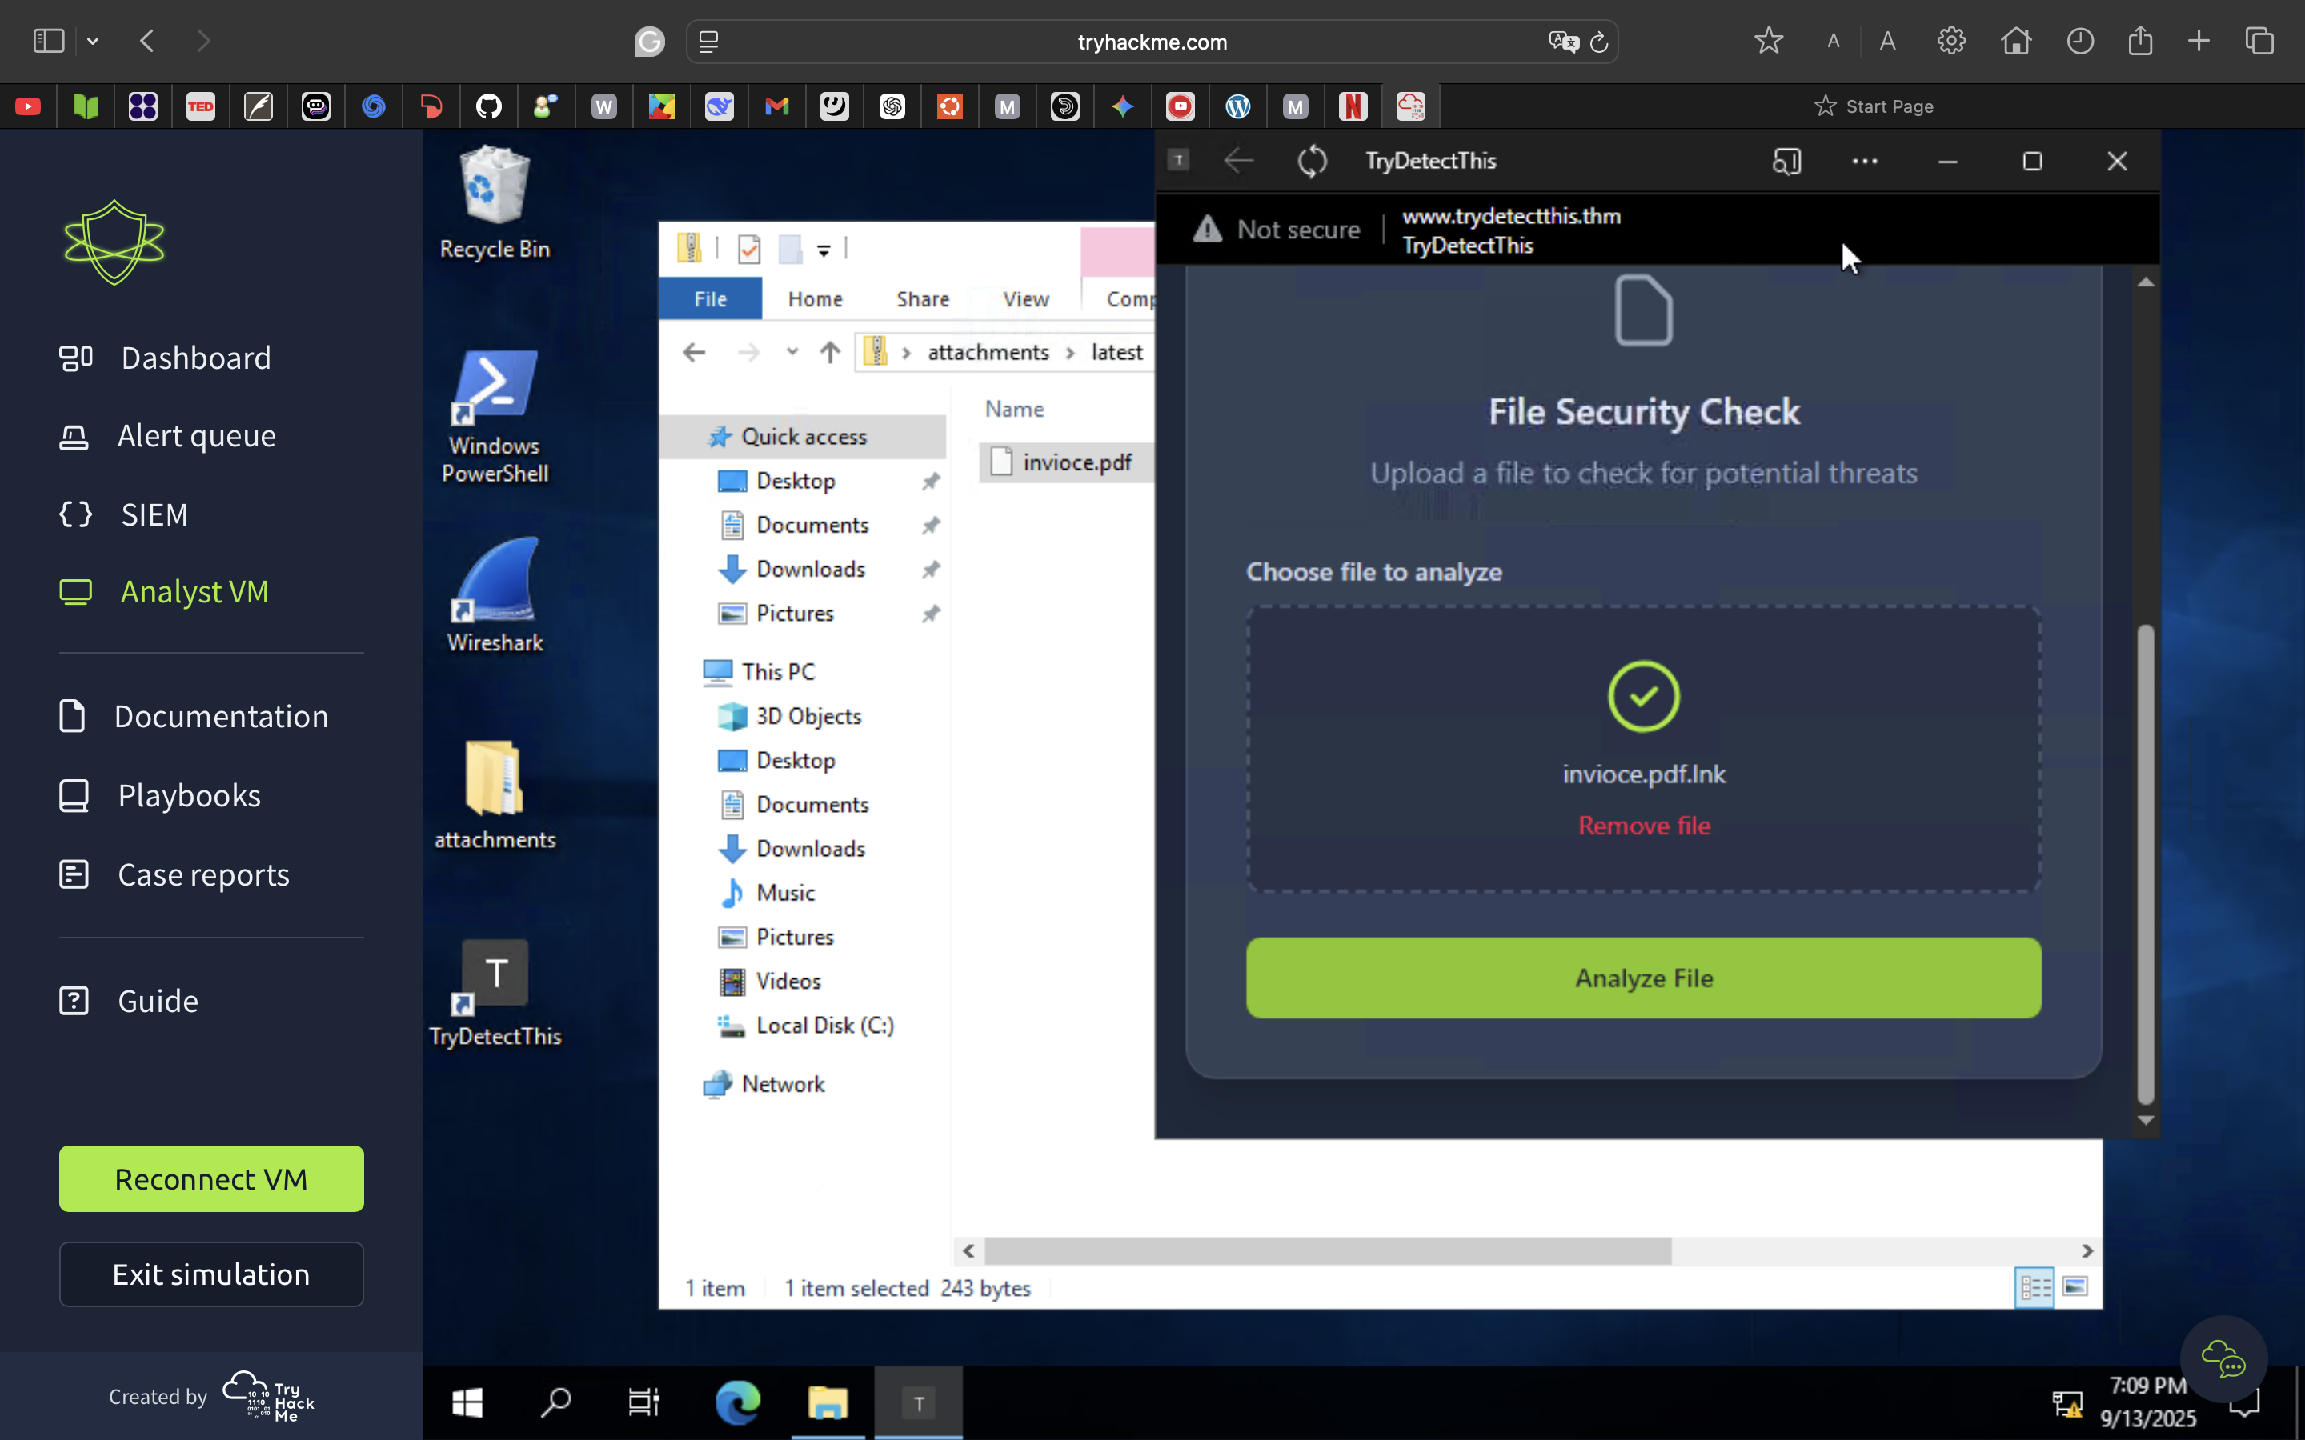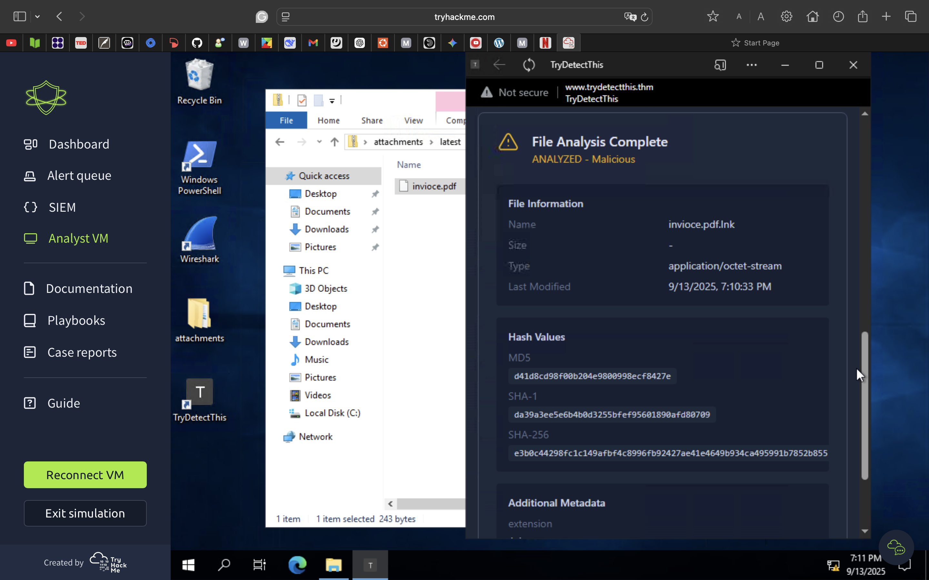

تنبيه ايميل مشبوهه ندخل على الملف اللي وصل منه الإيميل ونتأكد منه:

ننسخ الملف ونرفقه في أداة TheDetectedThis:

برنامج خبيث كذا تأكدنا انه خطر:

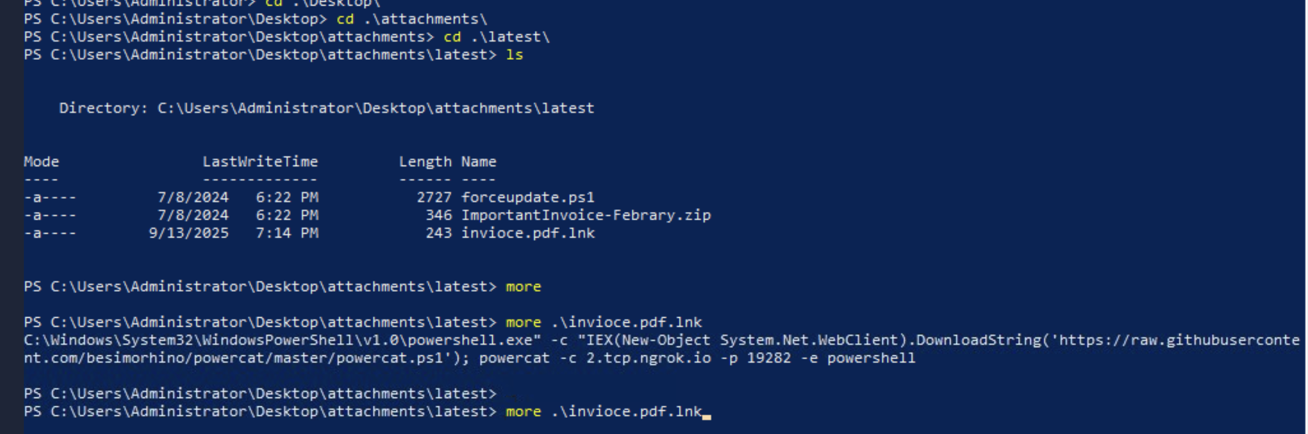

من الPowerShell ندخل موقع الملف ونكتب امر more يطلع لنا معلومات زياده

ونشوف ان المهاجم استخدم Powercat عشان يدخل للجهاز ويشارك الملف الضار:

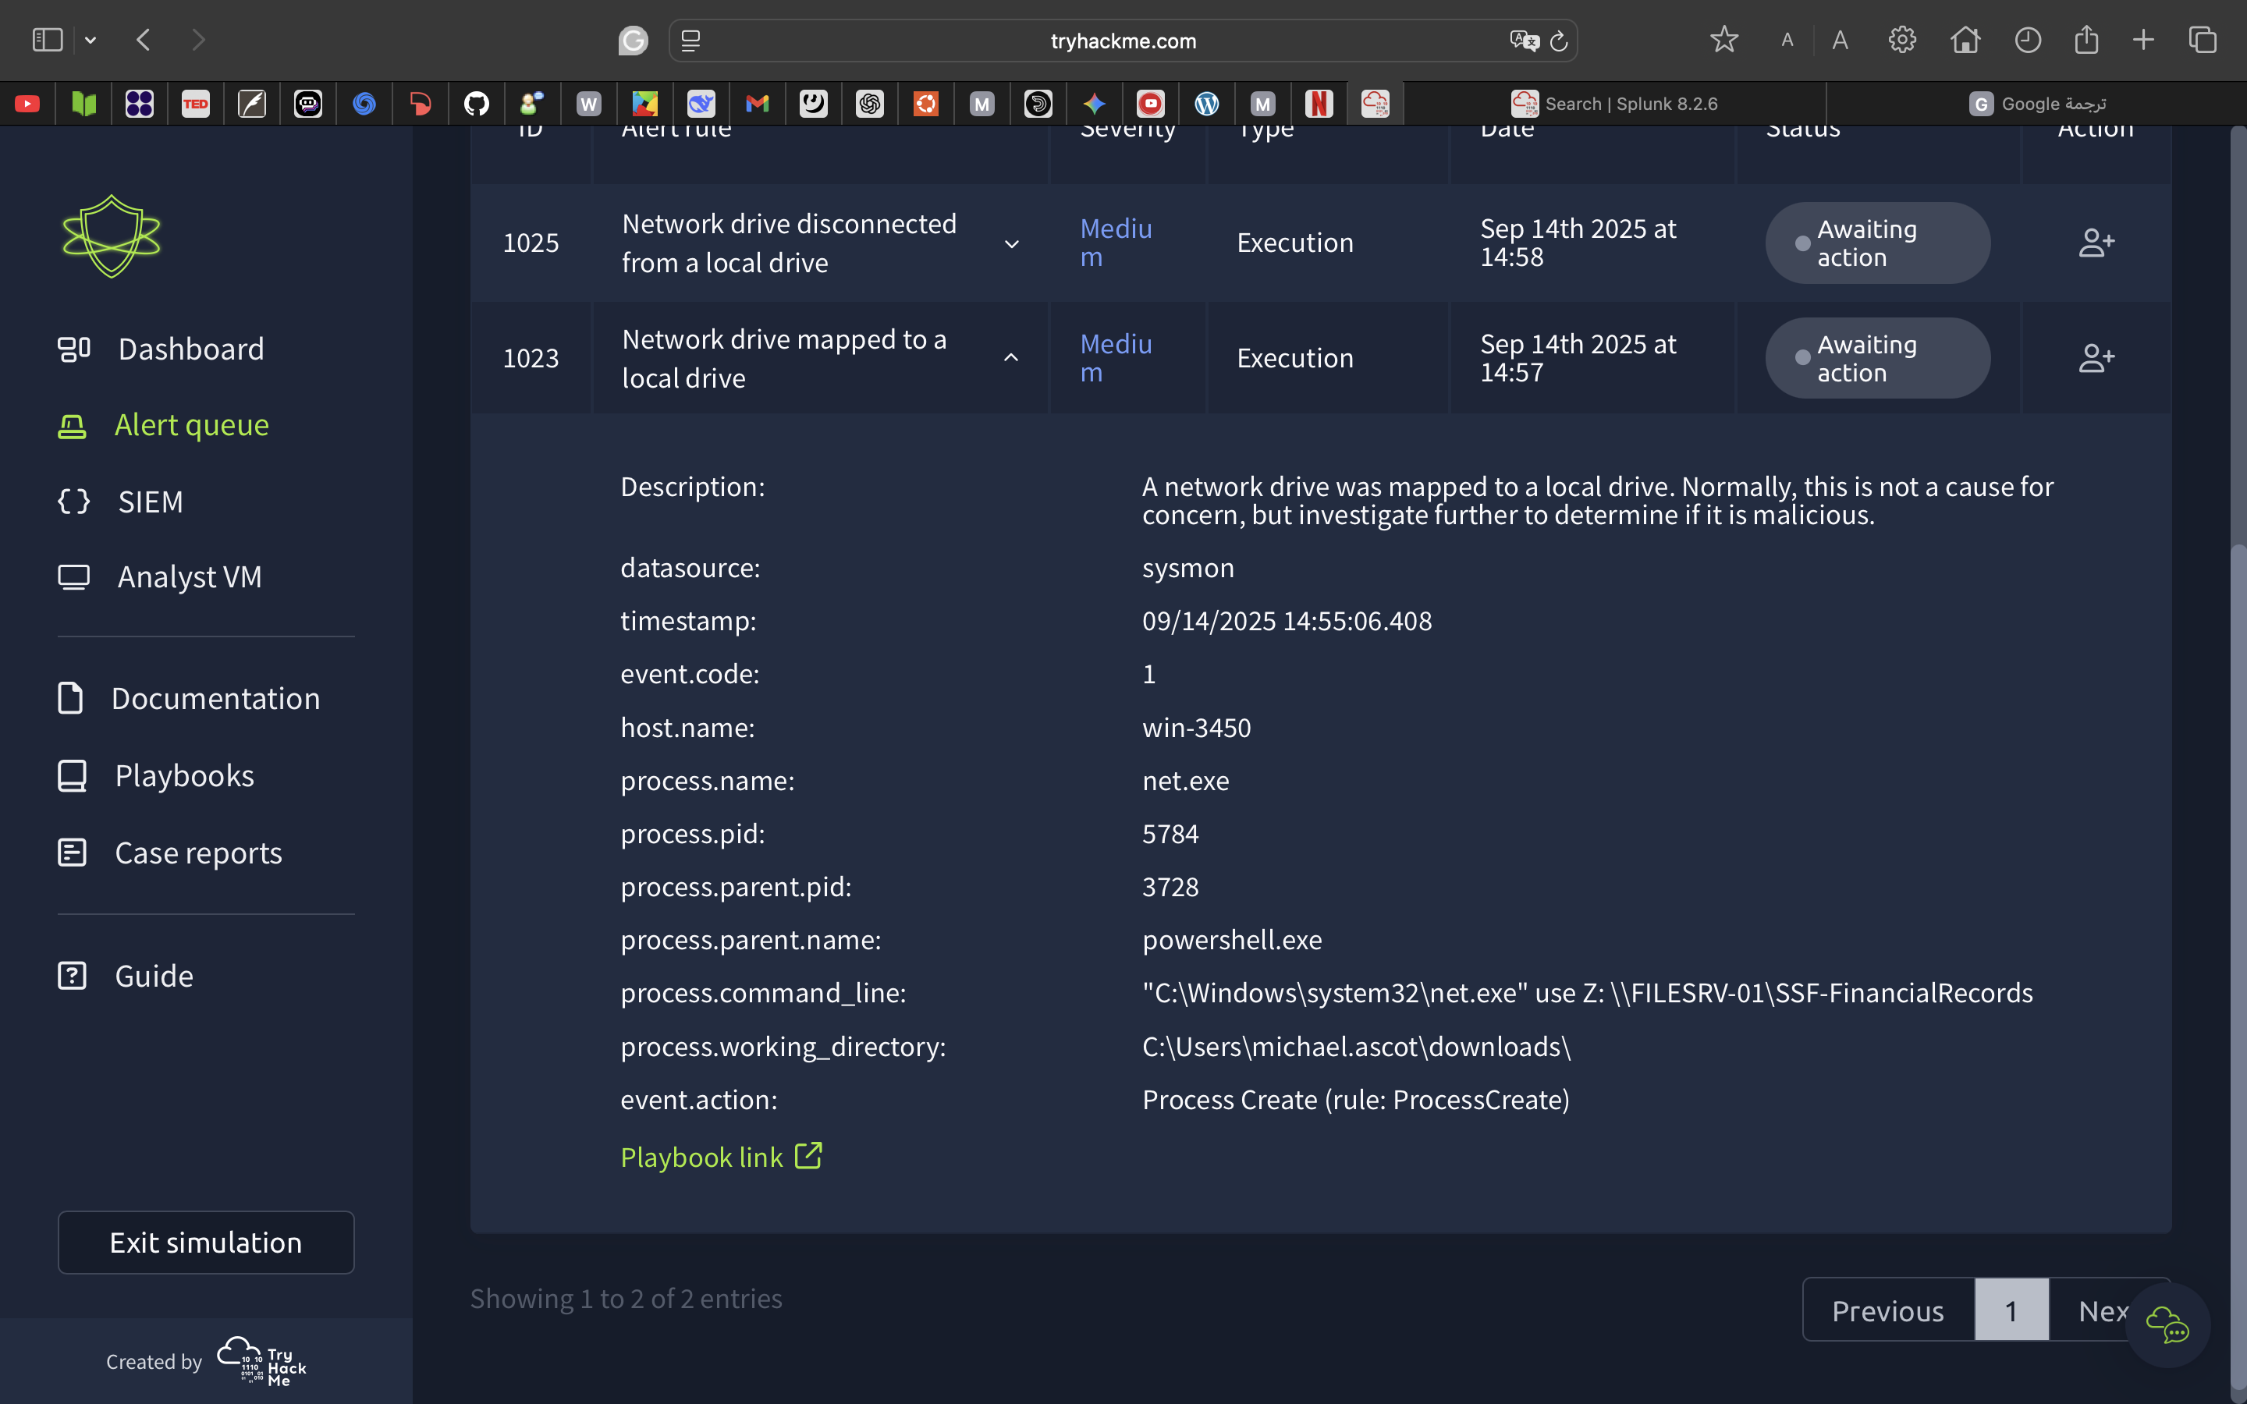

تنبيه عن ربط محرك اقراص مشبوهه بالشبكه

نروح على الSIEM ونتأكد من الموضوع:

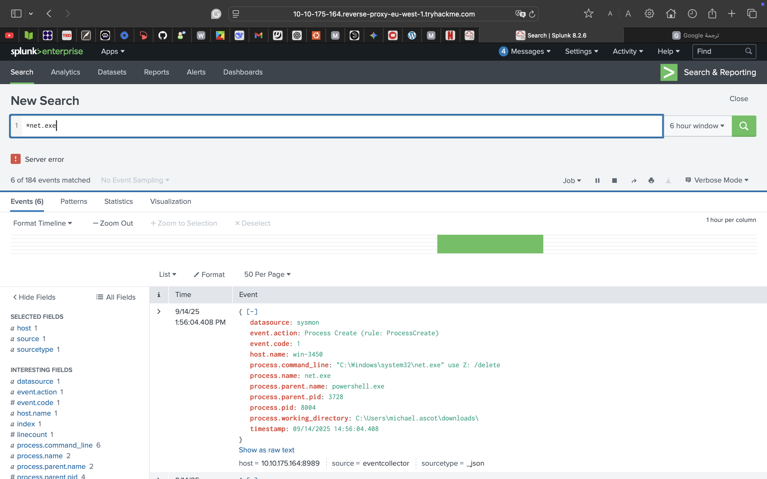

Caption

نبحث عن اسم العمليه بعدها نشوف كل شي عمله المهاجم.

نلاحظ ان المهاجم سجل دخول عبر الPowerShell وبعدها نفّذ أمر ربط مشاركّة شبكة كـ محرك أقراص.

"C:\Windows\system32\net.exe" use Z: \\FILESRV-01\SSF-FinancialRecords

بعدها شارك الملفات ثم حذف الربط يعني فكّ مشاركة الشبكة اللي كانت مركبة على القرص

"C:\Windows\system32\net.exe" use Z: /delete

كذا تأكدنا ان التنبيه خطير.

Time of Alert: 09/22/2025 15:20:17.817

**Related Entities:**

Sender: boone@hatventuresworldwide.online

Recipient: miguel.odonnell@tryhatme.com

**Reason for False Positive:**

* The email appeared to be a phishing attempt, aiming to trick the user into clicking a link and paying for “shipping.” However, it did not result in any compromise or harmful activity.
* No further action is required.

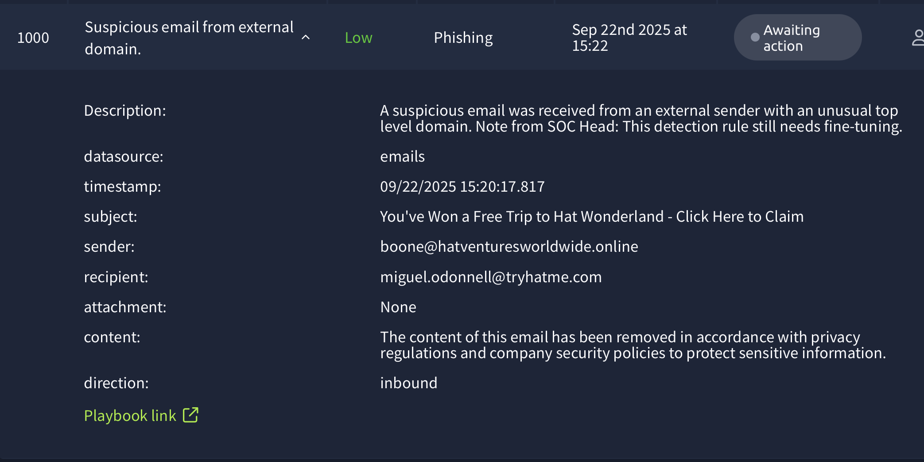

Time of Alert: 09/22/2025 15:31:01.817

**Related Entities:**

Sender: john@hatmakereurope.xyz

Recipient: michael.ascot@tryhatme.com

**Reason for False Positive:**

* Its look like a Phishing Email
* No further action is required.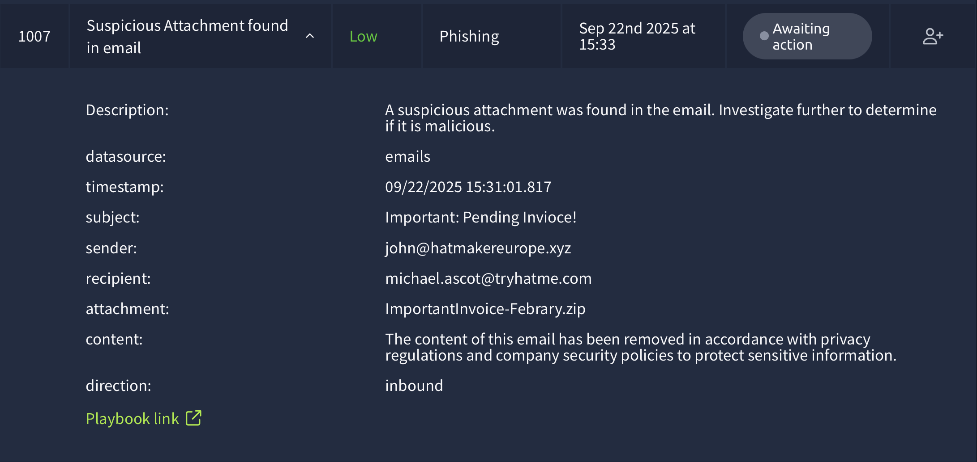

Time of Alert: 09/22/2025 15:21:17.817

**Related Entities:**

Sender: maximillian@chicmillinerydesigns.de

Recipient: michelle.smith@tryhatme.com

**Reason for False Positive:**

* The email appeared to be a phishing attempt
* No further action is required.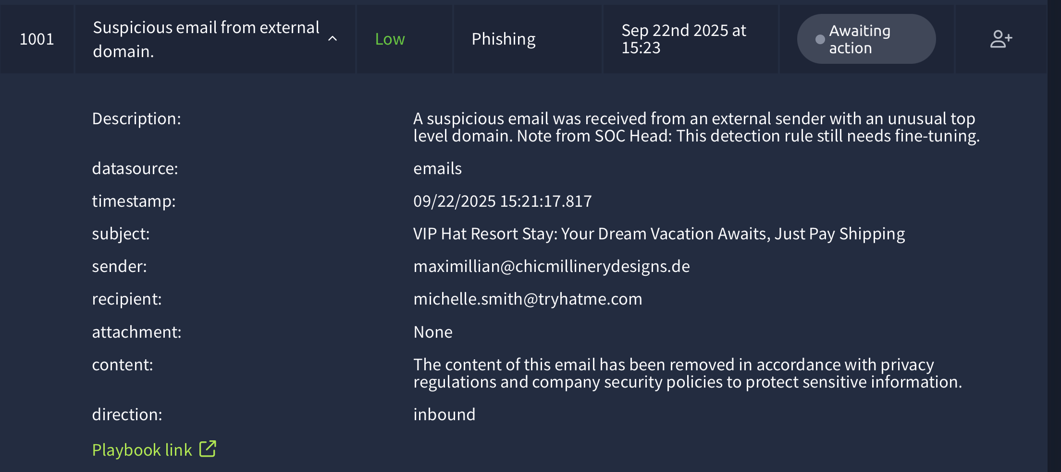

Time of Alert: 09/22/2025 15:26:21.817

**Related Entities:**

Sender: yani.zubair@tryhatme.com

Recipient: michelle.smith@tryhatme.com

**Reason for False Positive:**

* Scanned "forceupdate.ps1" on TryDetectThis and it comes up clean.
* No further action is required.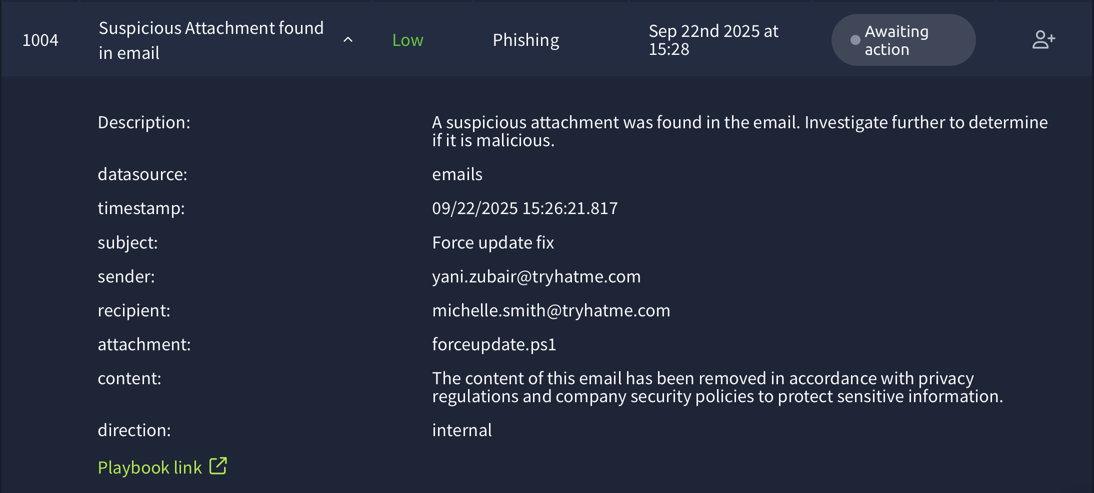

Time of Alert: 09/22/2025 15:32:17.817

**Related Entities:**

Sender: le@trendymillineryco.me

Recipient: ceo@tryhatme.com

**Reason for False Positive:**

* The email appeared to be a phishing attempt
* No attachment
* No further action is required.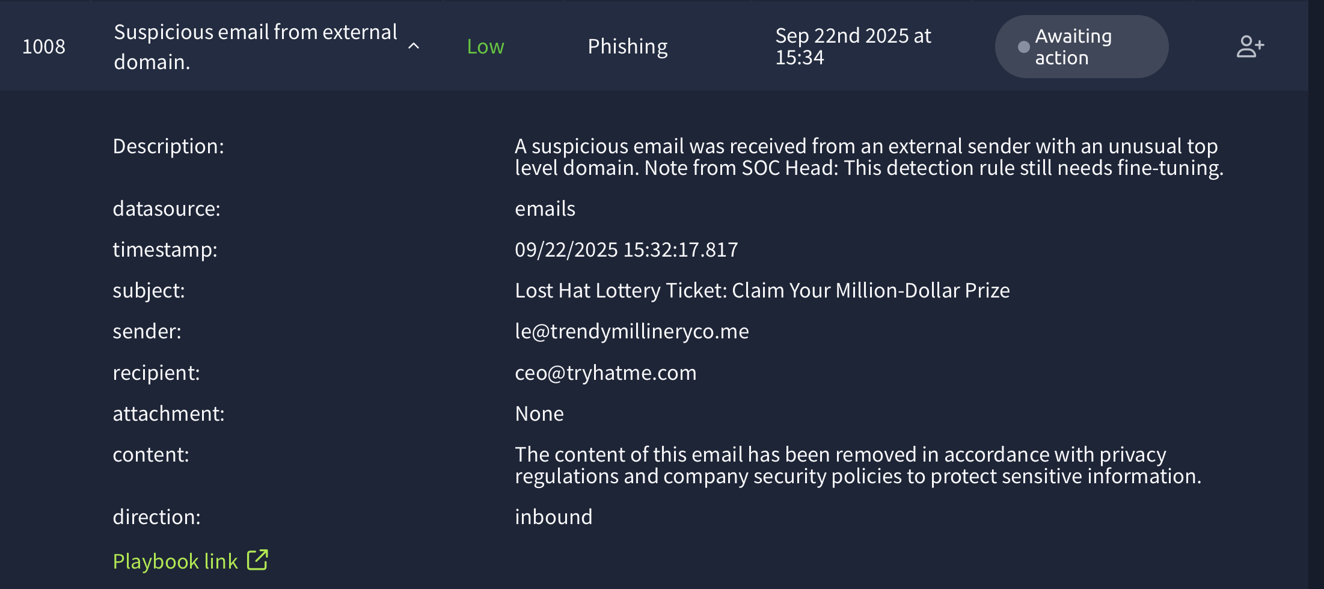

Time of Alert: 09/22/2025 15:35:41.817

**Related Entities:**

Sender: yani.zubair@tryhatme.com

Recipient: conor@modernmillinerygroup.online

**Reason for False Positive:**

* No domains scanned and are clean
* Looking to be like phishing emails.
* No action needed.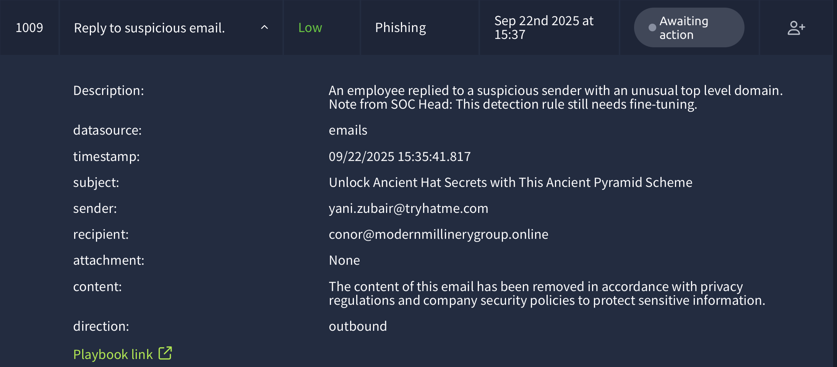

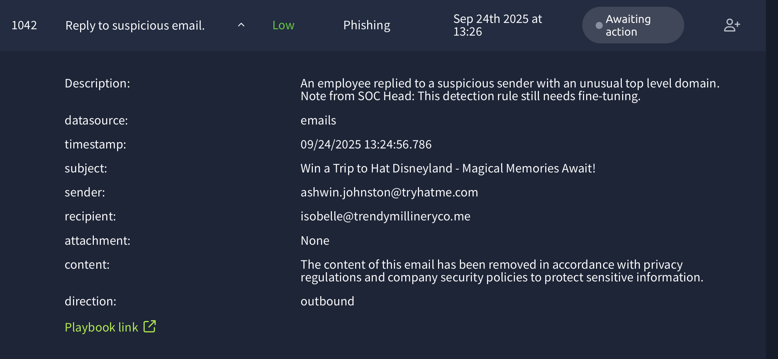

Time of Alert: 09/22/2025 15:24:56.817

**Related Entities:**

Sender: ashwin.johnston@tryhatme.com

Recipient: isobelle@trendymillineryco.me

**Reason for False Positive:**

* The email appeared to be a phishing attempt
* No attachment
* No further action is required.

Time of Alert: 09/22/2025 15:39:07.817

**Related Entities:**

Sender: armaan.terry@tryhatme.com

Recipient: stark@modernmillinerygr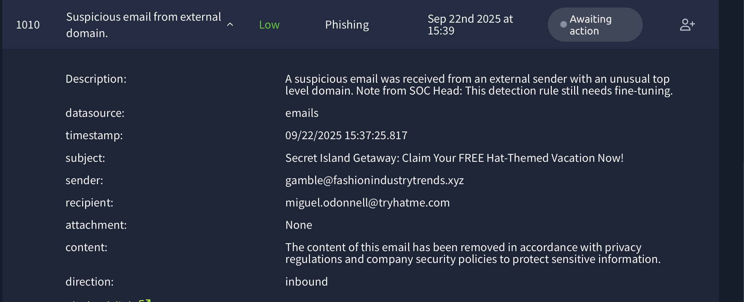oup.online

**Reason for False Positive:**

* No domains scanned and are clean
* Looking to be like phishing emails.
* No action needed.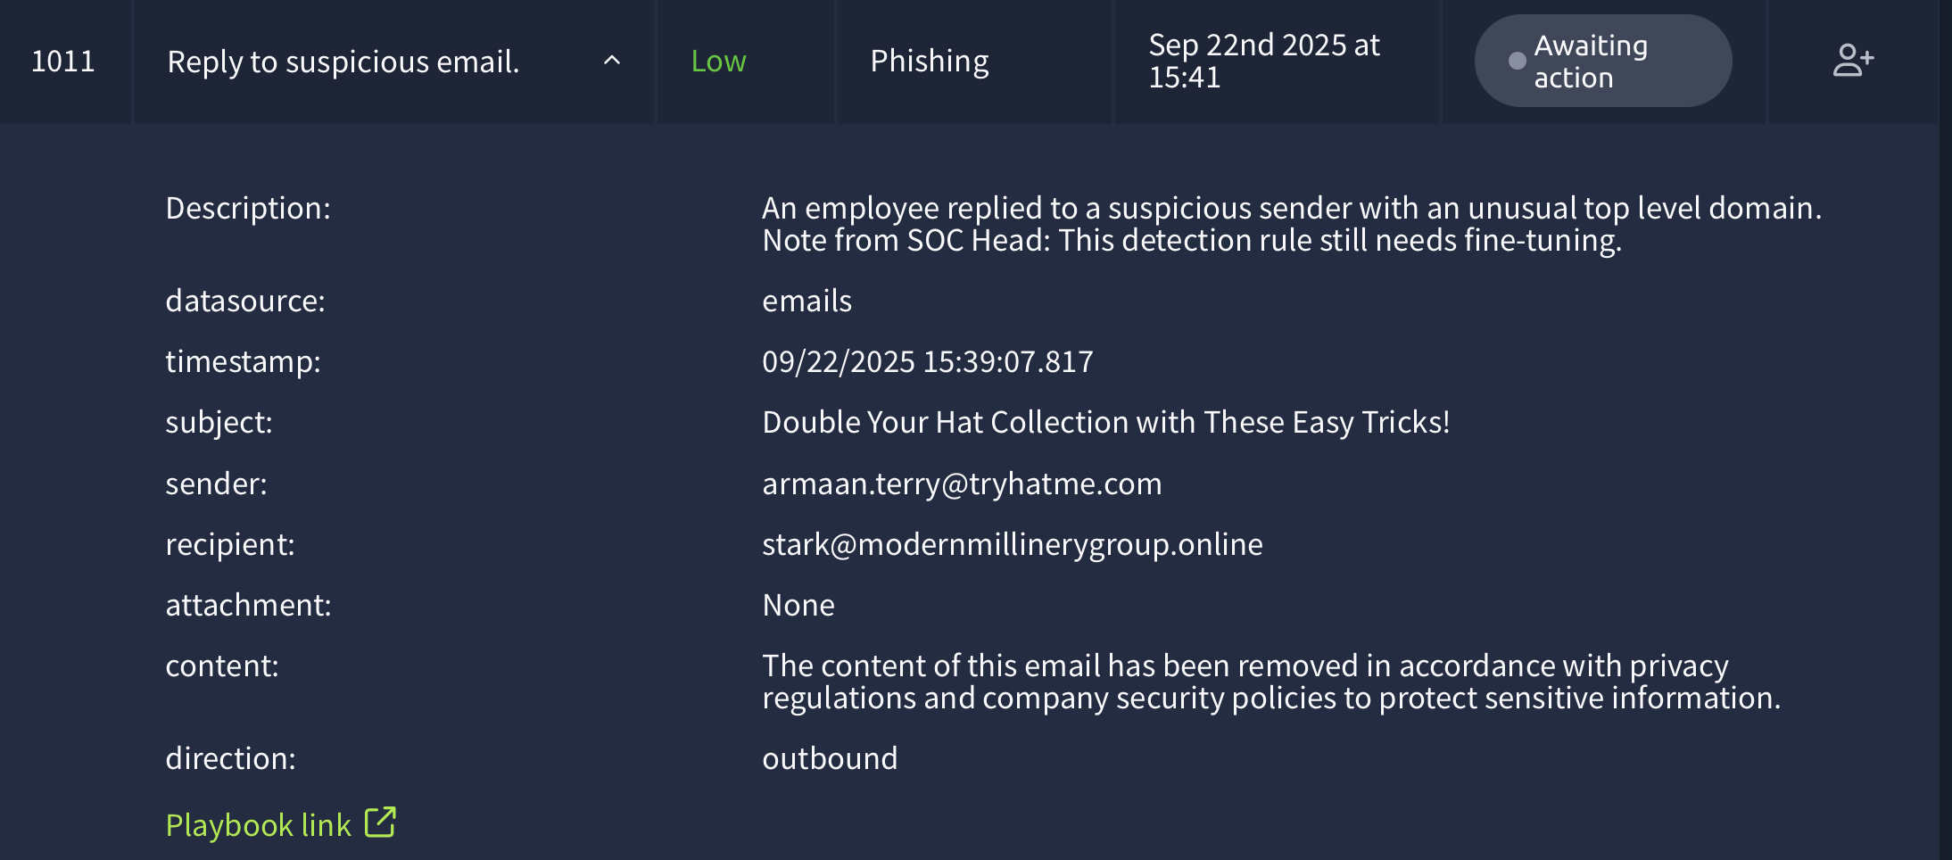

Time of Alert: 09/22/2025 15:39:45.817

**Related Entities:**

Sender: sharp@hatsontherise.online

Recipient: miguel.odonnell@tryhatme.com

**Reason for False Positive:**

* The email appeared to be a phishing attempt
* No attachment
* No further action is required.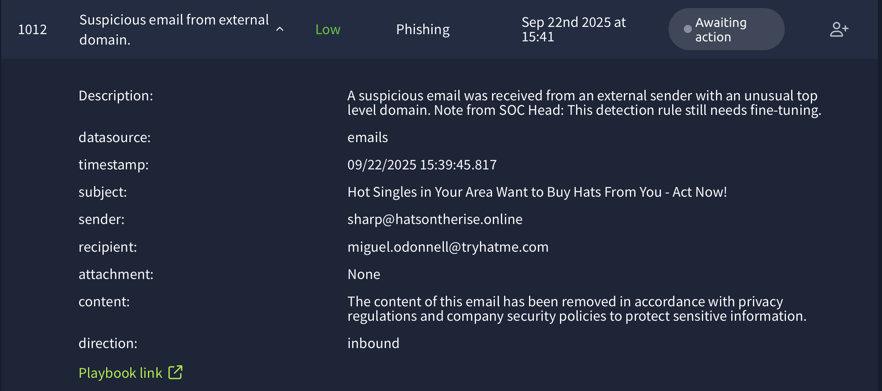

Time of Alert: 09/22/2025 15:41:16.817

**Related Entities:**

Sender: michelle.smith@tryhatme.com

Recipient: yani.zubair@tryhatme.com

**Reason for False Positive:**

* Scanned "forceupdate.ps1" on TryDetectThis and it comes up clean.
* No further action is required.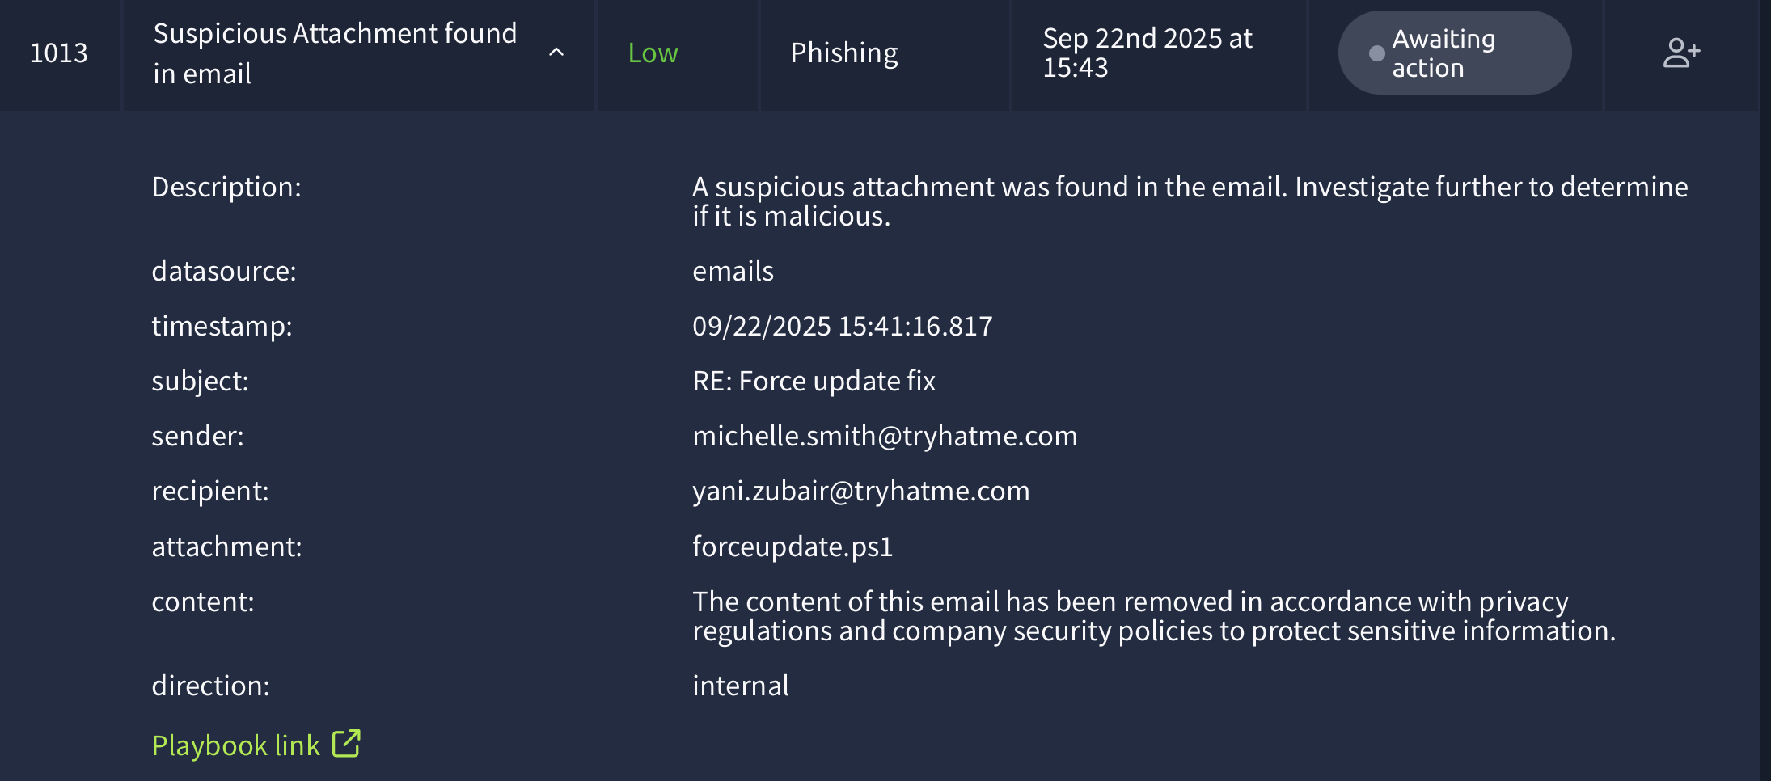

Time of Alert: 09/22/2025 15:41:44.817

**Related Entities:**

Sender: elle@headwearinnovations.online

Recipient: liam.espinoza@tryhatme.com

**Reason for False Positive:**

* The email appeared to be a phishing attempt
* No attachment
* No further action is required.

Time of Alert: 09/22/2025 15:43:43.817

**Related Entities:**

process.name: TrustedInstaller.exe

process.pid: 3949

process.parent.pid: 3714

process.parent.name: serv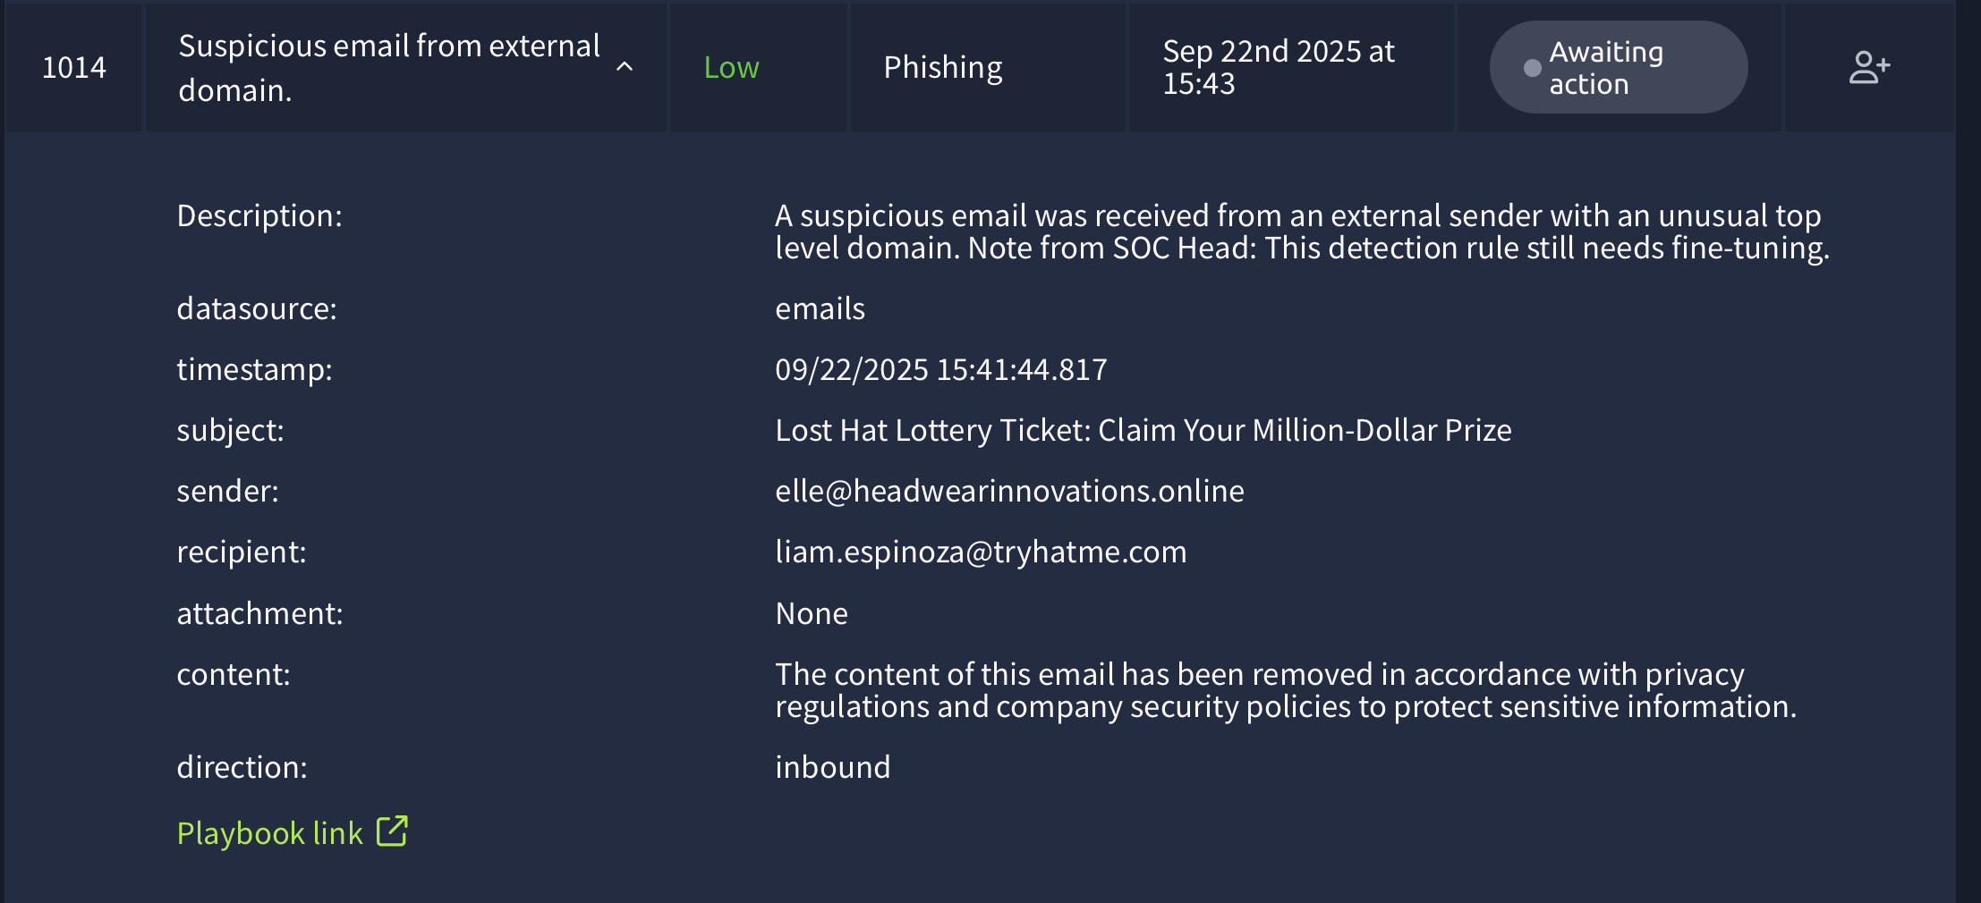ices.exe

process.command_line: C\Windows\servicing\TrustedInstaller.exe

**Reason for False Positive:**

* These are Normal services running.
* No further action needed.

Time of Alert: 09/22/2025 15:44:42.817

**Related Entities:**

process.name: TrustedInstaller.exe

process.pid: 3817

process.parent.pid: 3922

process.parent.name: serv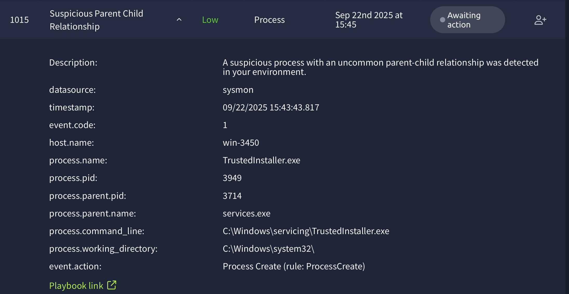ices.exe

process.command_line: C\Windows\servicing\TrustedInstaller.exe

**Reason for False Positive:**

* These are Normal services running.
* No further action needed.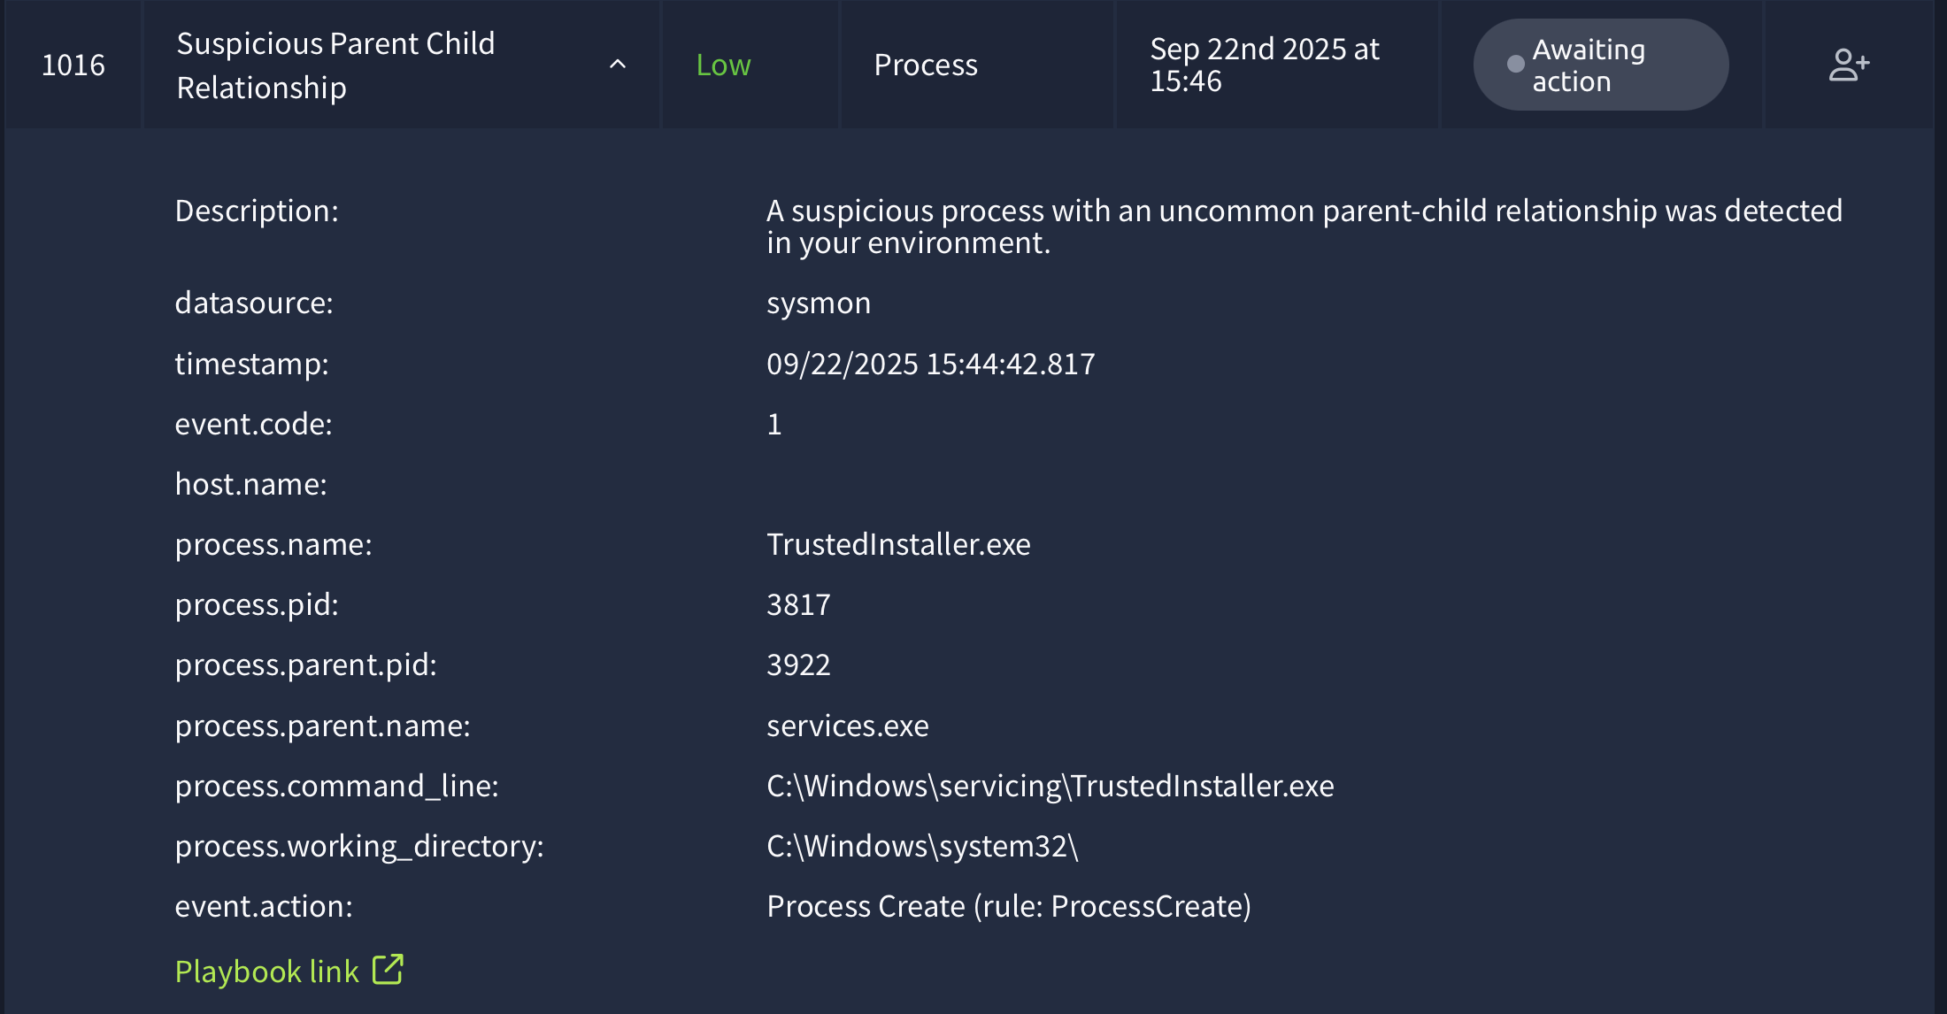

Time of Alert: 09/22/2025 15:56:11.817

**Related Entities:**

process.name: nslookup.exe

process.pid: 3800

process.parent.pid: 3728

process.parent.name: powershell.exe

process.command_line: "C:\Windows\system32\nslookup.exe" nLz8nMDy7NzU0sqtSryCmu4OVyprsk.haz4rdw4re.io

**Reason for False Positive:**

* These are Normal services running.
* No further action needed.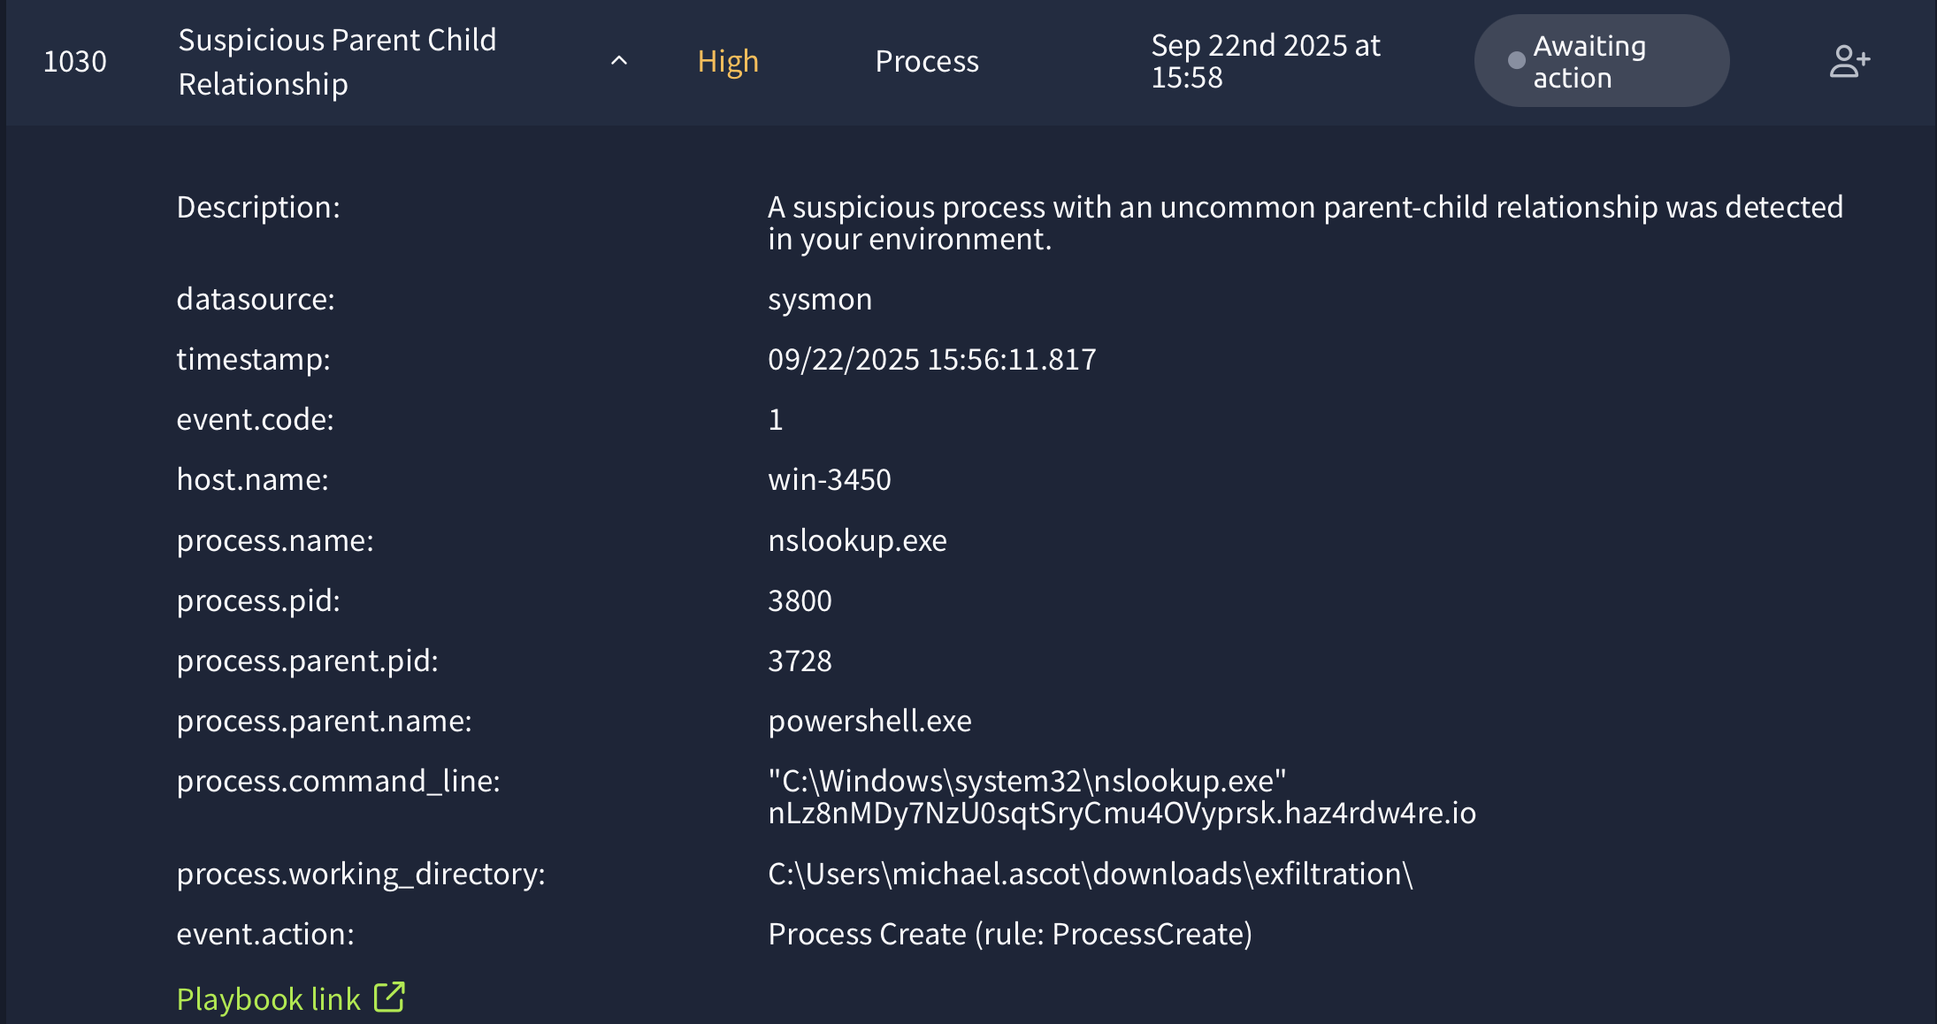

Time of Alert: 09/22/2025 15:56:11.817

**Related Entities:**

process.name: nslookup.exe

process.pid: 5520

process.parent.pid: 3728

process.parent.name: powershell.exe

process.command_line: "C:\Windows\system32\nslookup.exe" nLz8nMDy7NzU0sqtSryCmu4OVyprsk.haz4rdw4re.io

**Reason for False Positive:**

* These are Normal services running.
* No further action needed.

Time of Alert: 09/22/2025 15:56:11.817

**Related Entities:**

process.name: nslookup.exe

process.pid: 5952

process.parent.pid: 3728

process.parent.name: powershell.exe

process.comman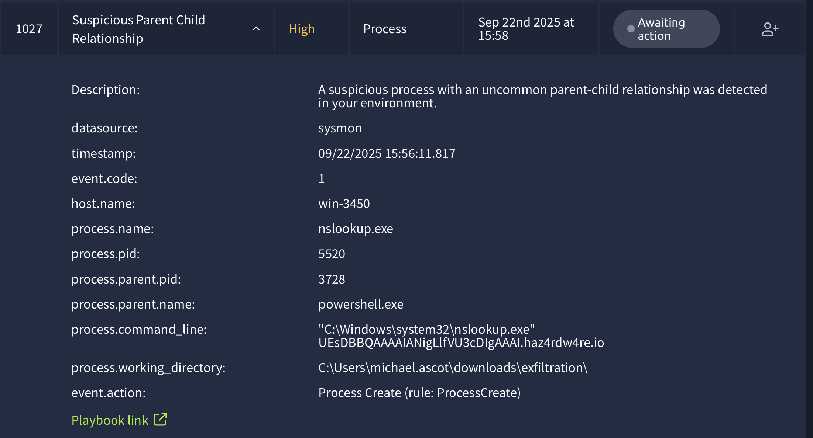d_line: "C:\Windows\system32\nslookup.exe" nLz8nMDy7NzU0sqtSryCmu4OVyprsk.haz4rdw4re.io

**Reason for False Positive:**

* These are Normal services running.
* No further action needed.

Time of Alert: 09/22/2025 15:56:27.817

**Related Entities:**

process.name: nslookup.exe

process.pid: 3648

process.parent.pid: 3728

process.parent.name: powershell.exe

process.co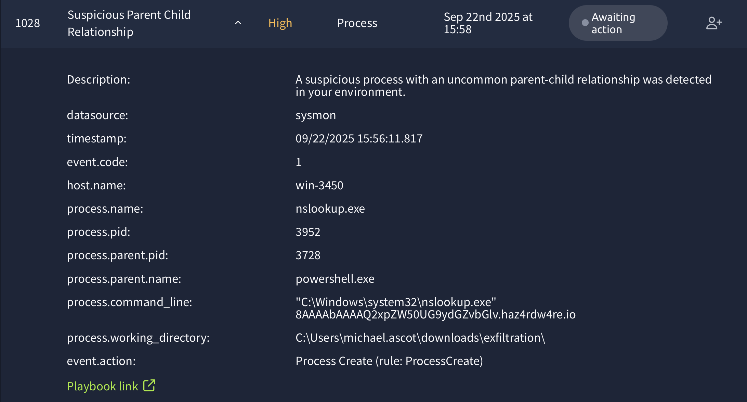mmand_line: "C:\Windows\system32\nslookup.exe" RmYjEyNGZiMTY1NjZlfQ==.haz4rdw4re.io

**Reason for False Positive:**

* These are Normal services running.
* No further action needed.

Time of Alert: 09/22/2025 15:56:27.817

**Related Entities:**

process.name: nslookup.exe

process.pid: 3700

process.parent.pid: 3728

process.parent.name: powershell.exe

process.comman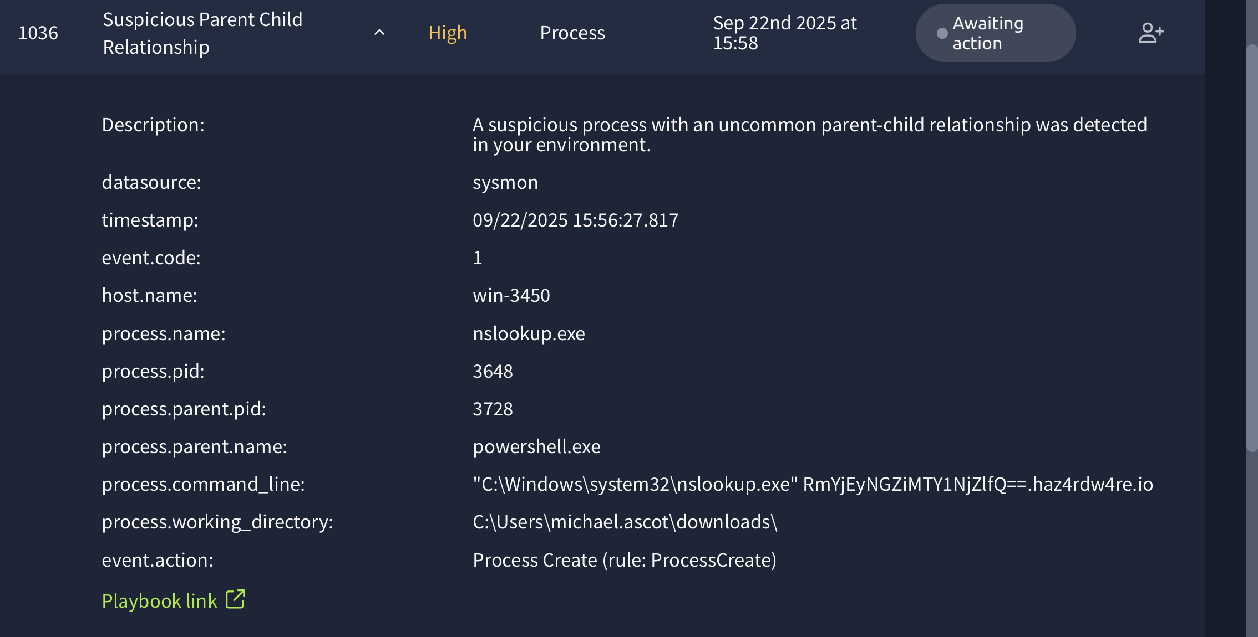d_line: "C:\Windows\system32\nslookup.exe" VEhNezE0OTczMjFmNGY2ZjA1OWE1Mm.haz4rdw4re.io

**Reason for False Positive:**

* These are Normal services running.
* No further action needed.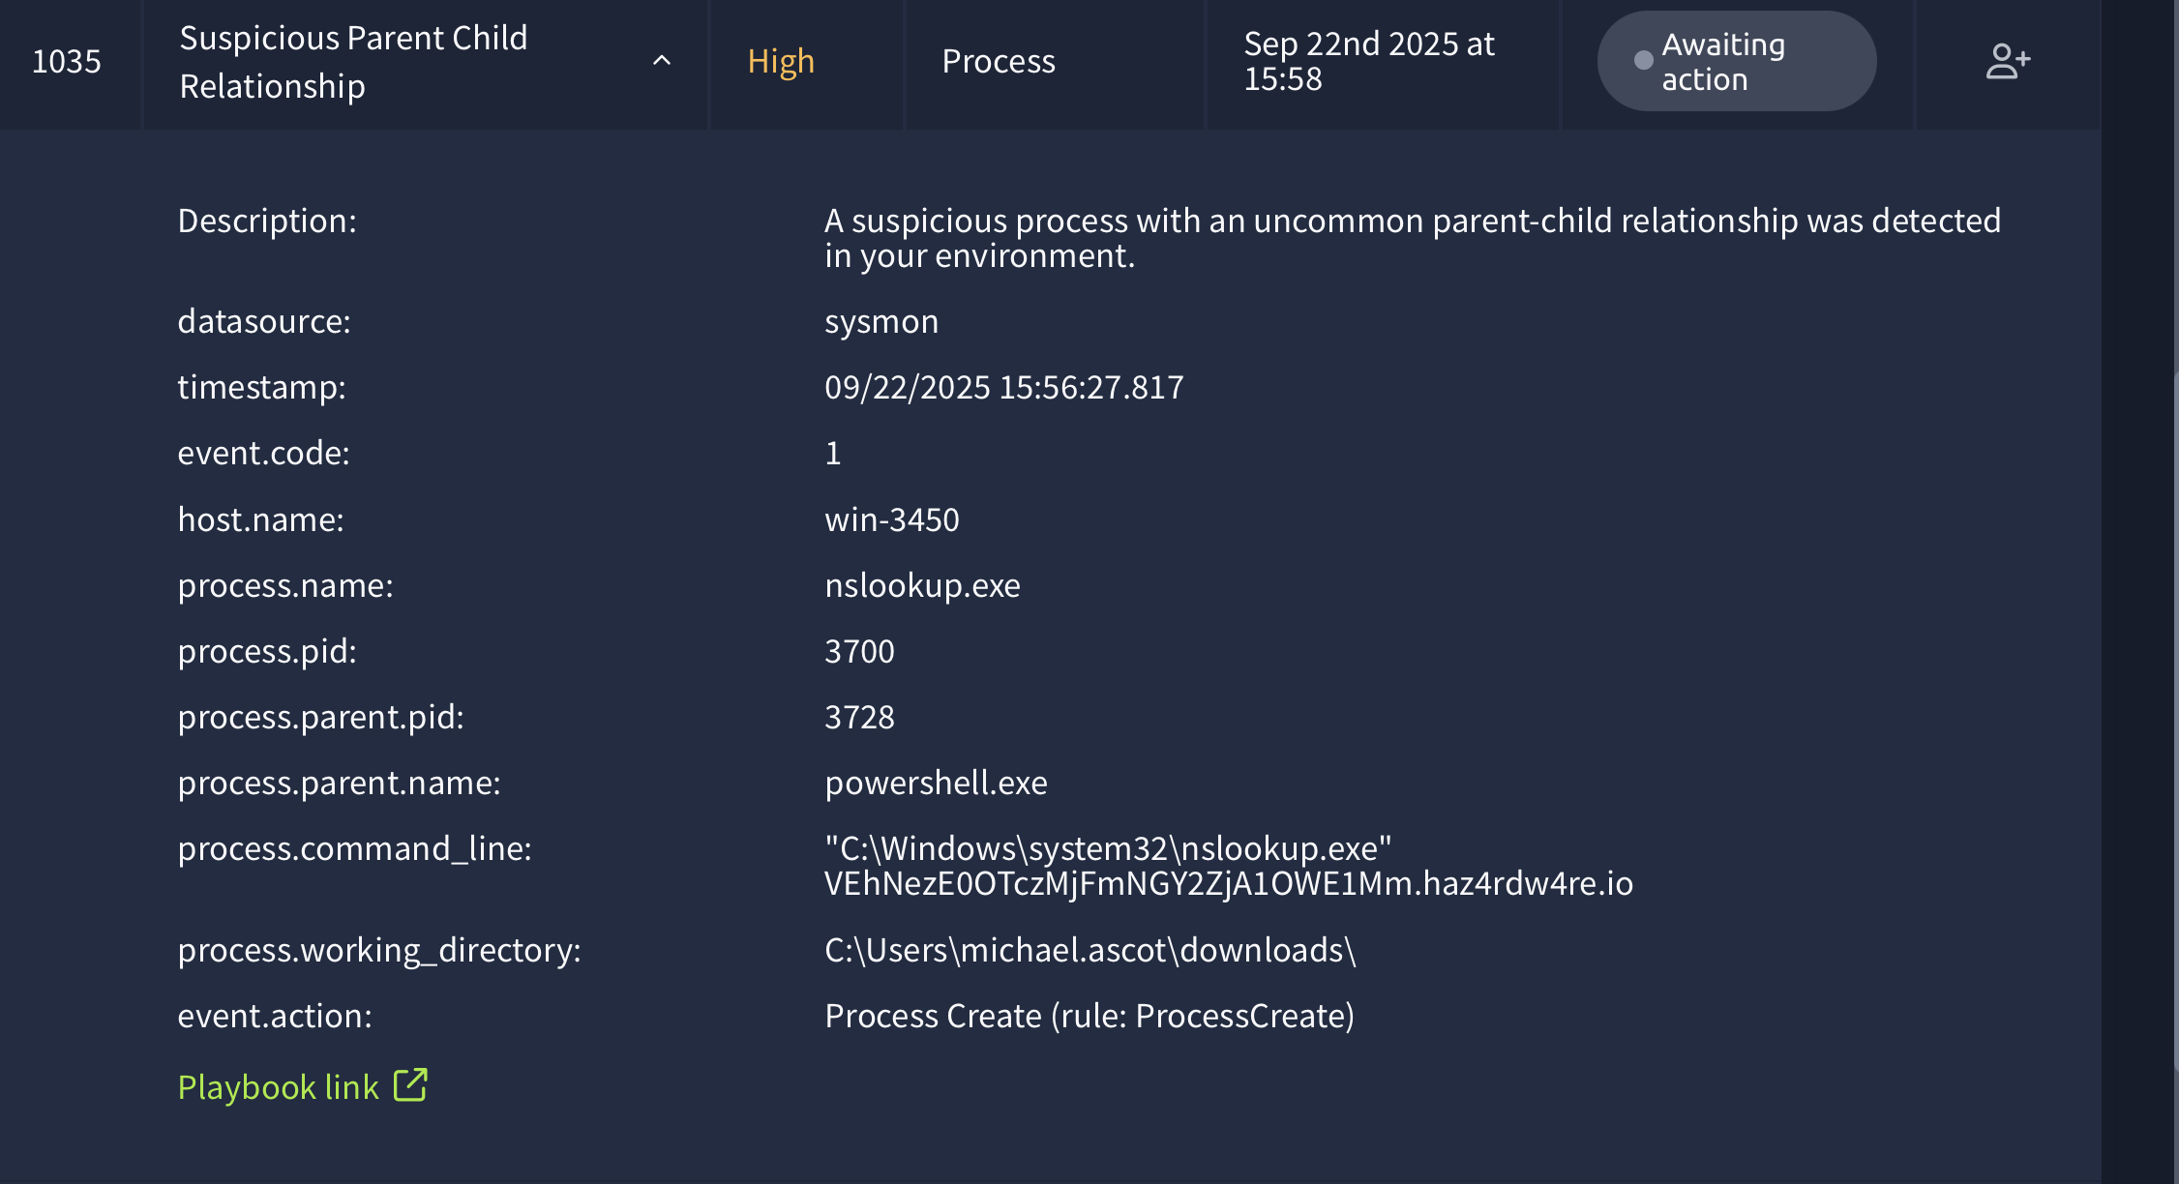

Time of Alert: 09/22/2025 15:23:26.817

**Related Entities:**

process.name: taskhostw.exe

process.pid: 3897

process.parent.pid: 3902

process.parent.name: svchost.exe

process.command_line: taskhostw.exe NGCKeyPregen

**Reason for False Positive:**

* These are Normal services running.
* No further action needed.

Time of Alert: 09/22/2025 15:24:43.817

**Related Entities:**

Sender: support@tryhatme.com

Recipient: warner@yahoo.com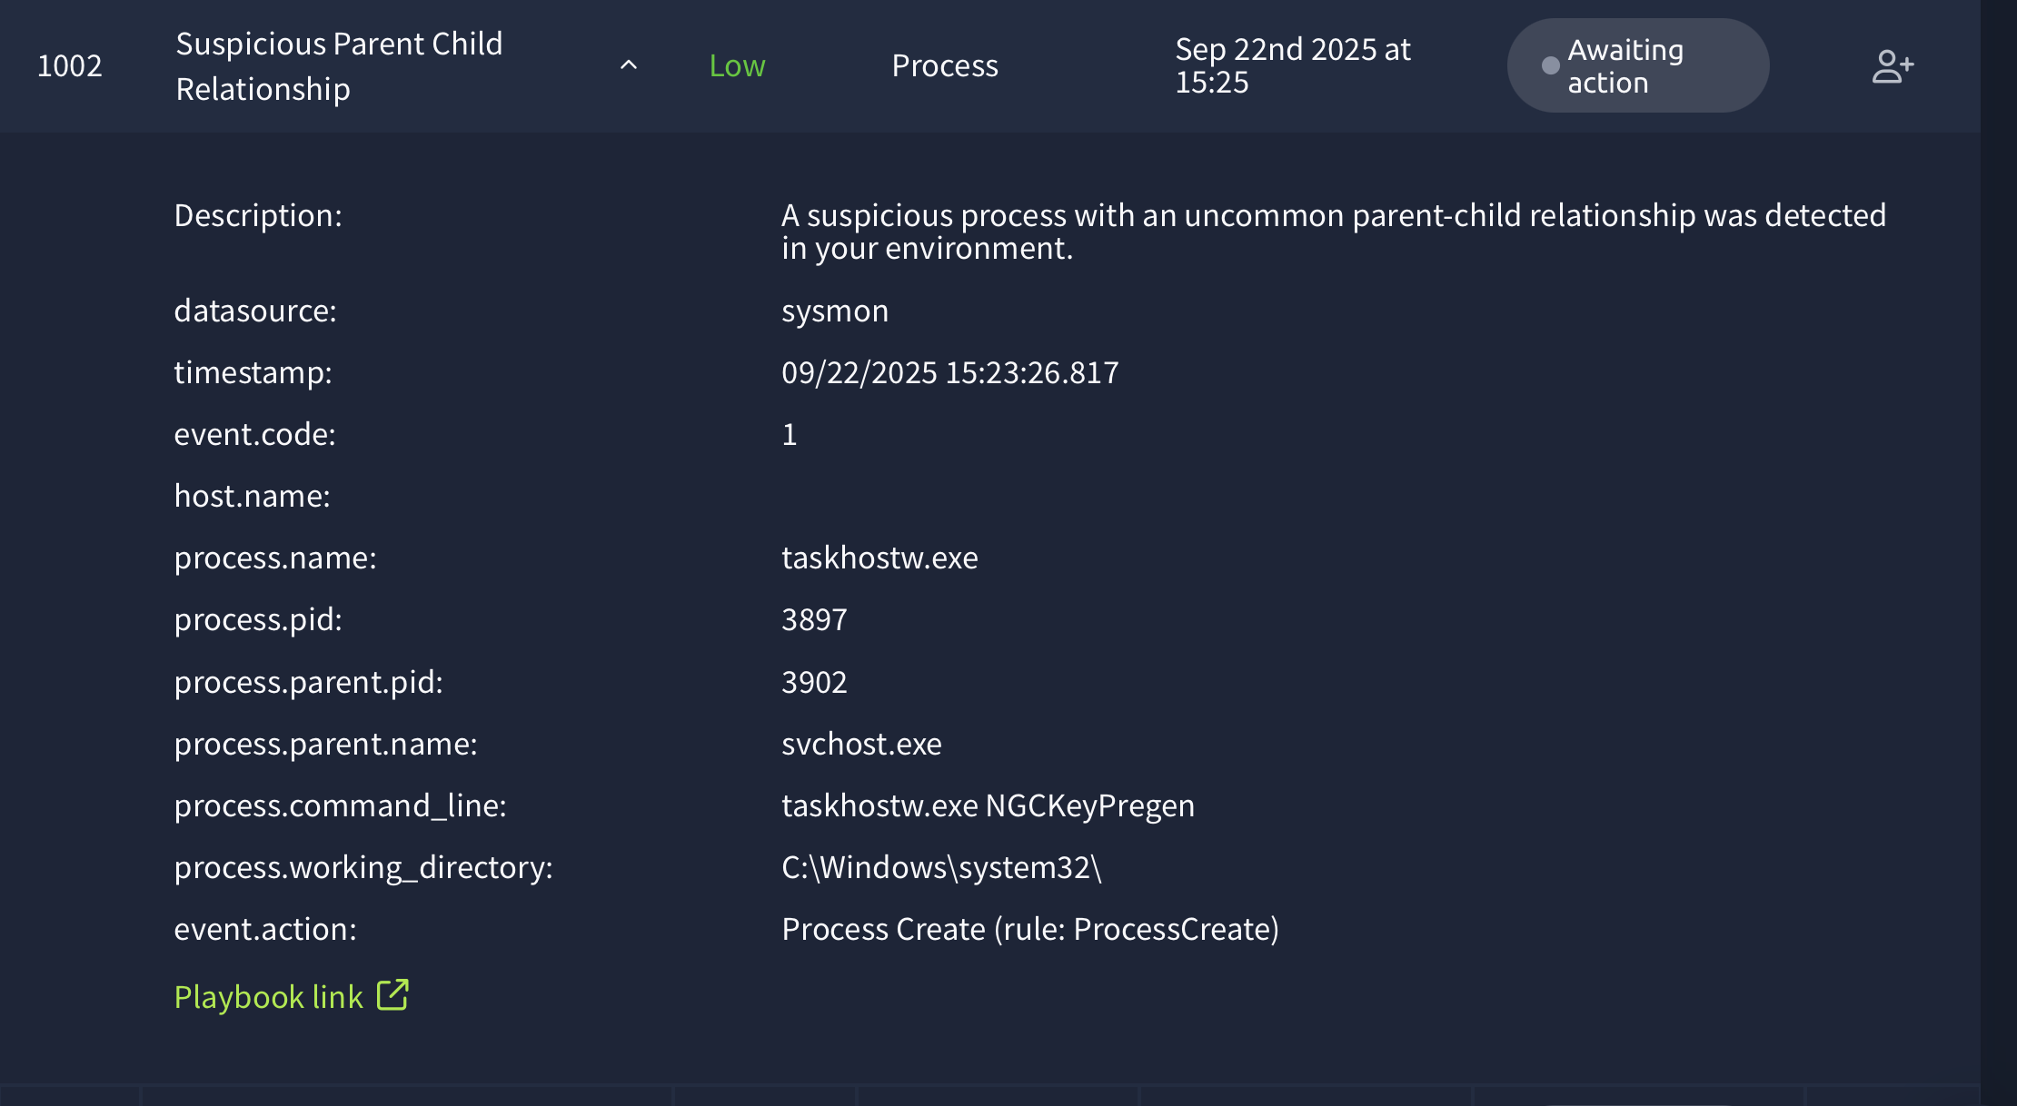

**Reason for False Positive:**

* No domains scanned and is clean
* Looking to be like phishing emails.
* No action needed.

Time of Alert: 09/22/2025 15:56:11.817

**Related Entities:**

process.name: nslookup.exe

process.pid: 5704

process.parent.pid: 3728

process.parent.name: powershell.exe

process.comman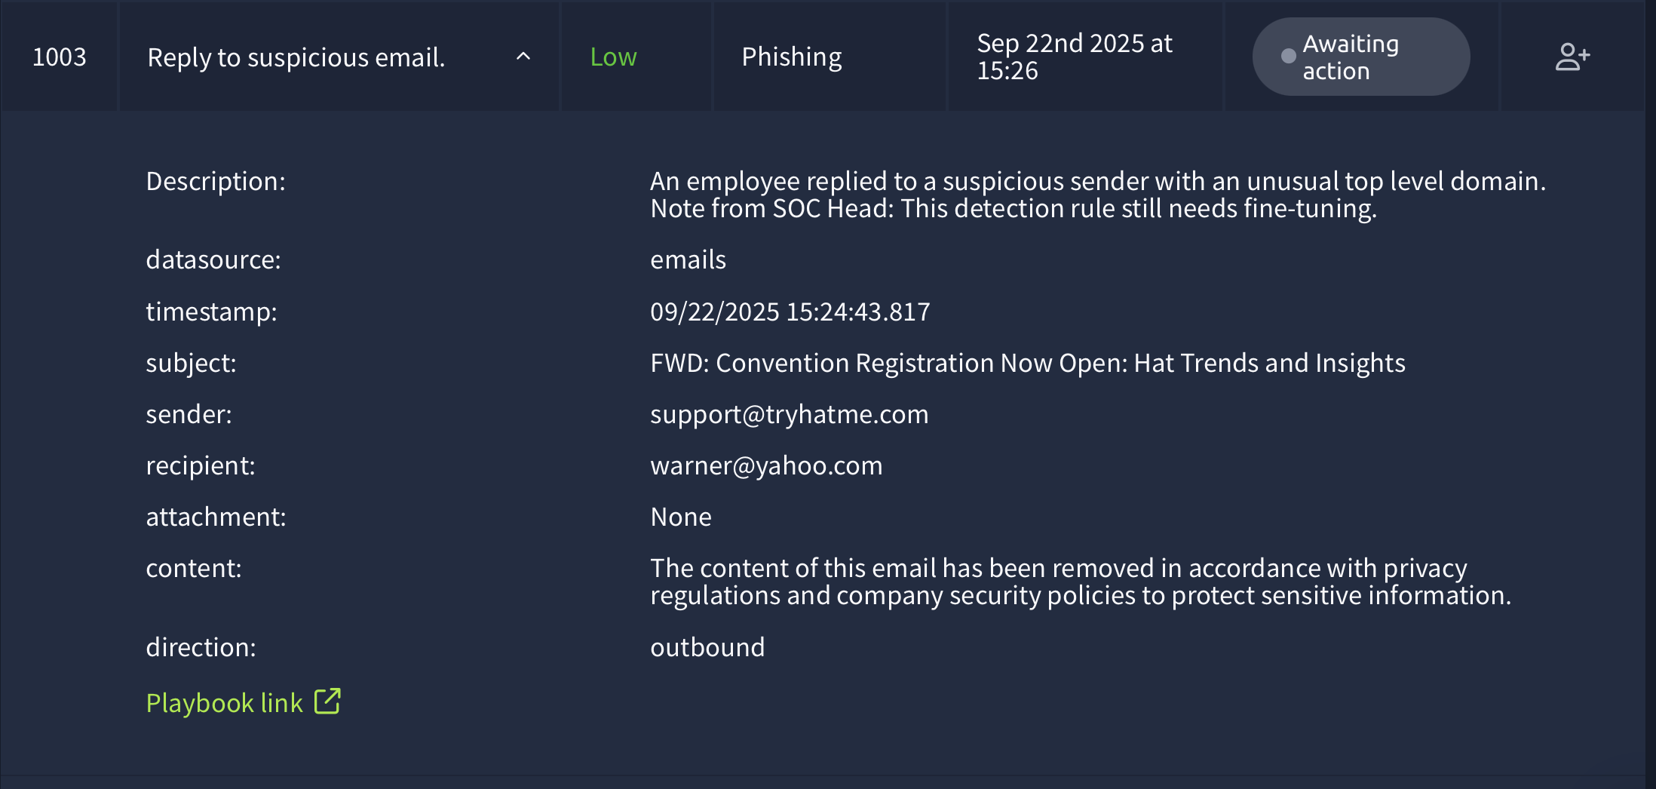d_line: "C:\Windows\system32\nslookup.exe" VEhNezE0OTczMjFmNGY2ZjA1OWE1Mm.haz4rdw4re.io

**Reason for False Positive:**

* These are Normal services running.
* No further action needed.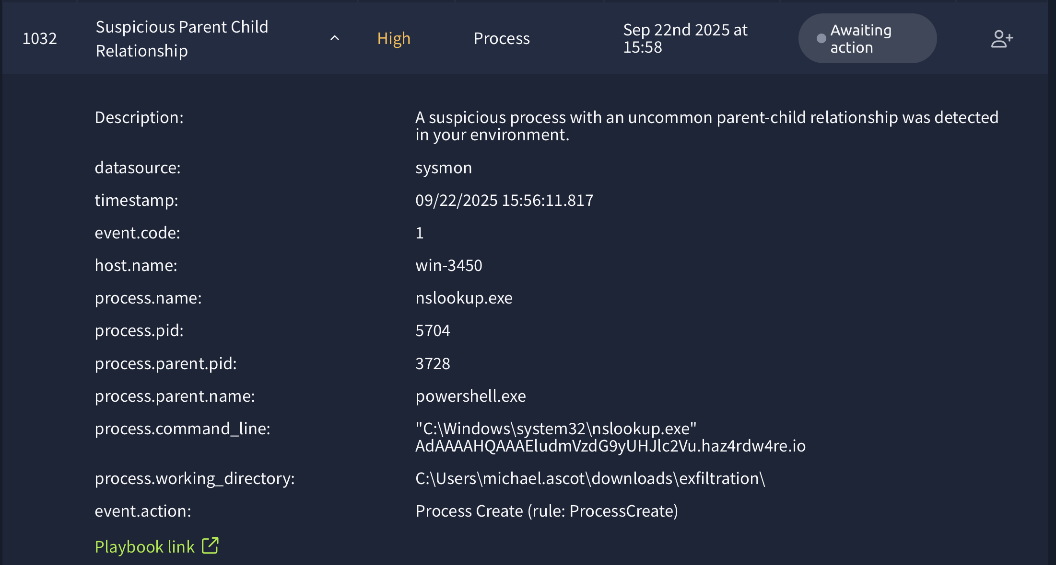

Time of Alert: 09/22/2025 15:49:22.817

**Related Entities:**

Sender: barker@yahoo.com

Recipient: yani.zubair@tryhatme.com

**Reason for False Positive:**

* The email appeared to be a phishing attempt
* No attachment
* No further action is required.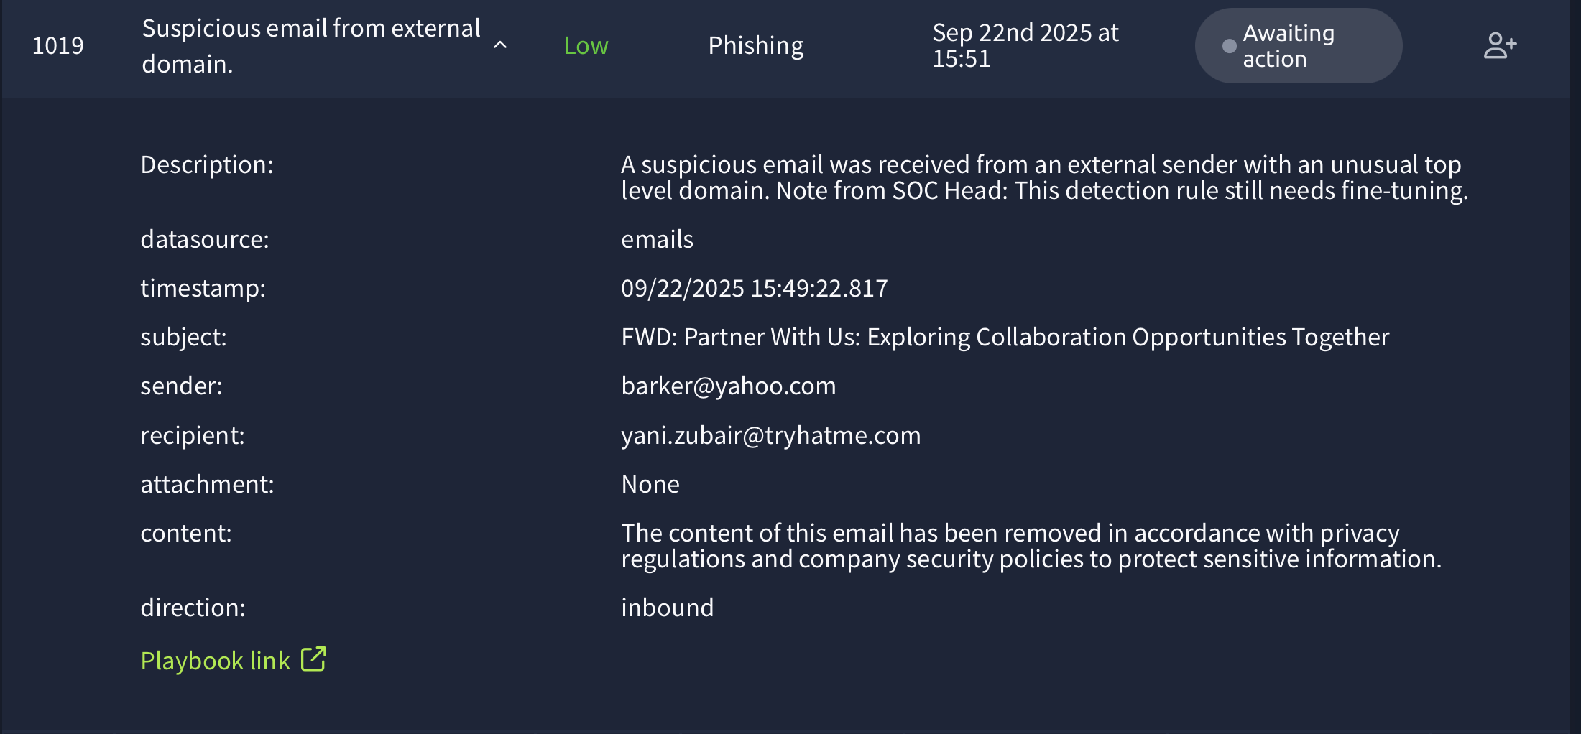

Time of Alert: 09/22/2025 15:28:38.817

**Related Entities:**

Sender: tim@chicmillinerydesigns.de

Recipient: invoice@tryhatme.com

**Reason for False Positive:**

* The email appeared to be a phishing attempt
* No attachment
* No further action is required.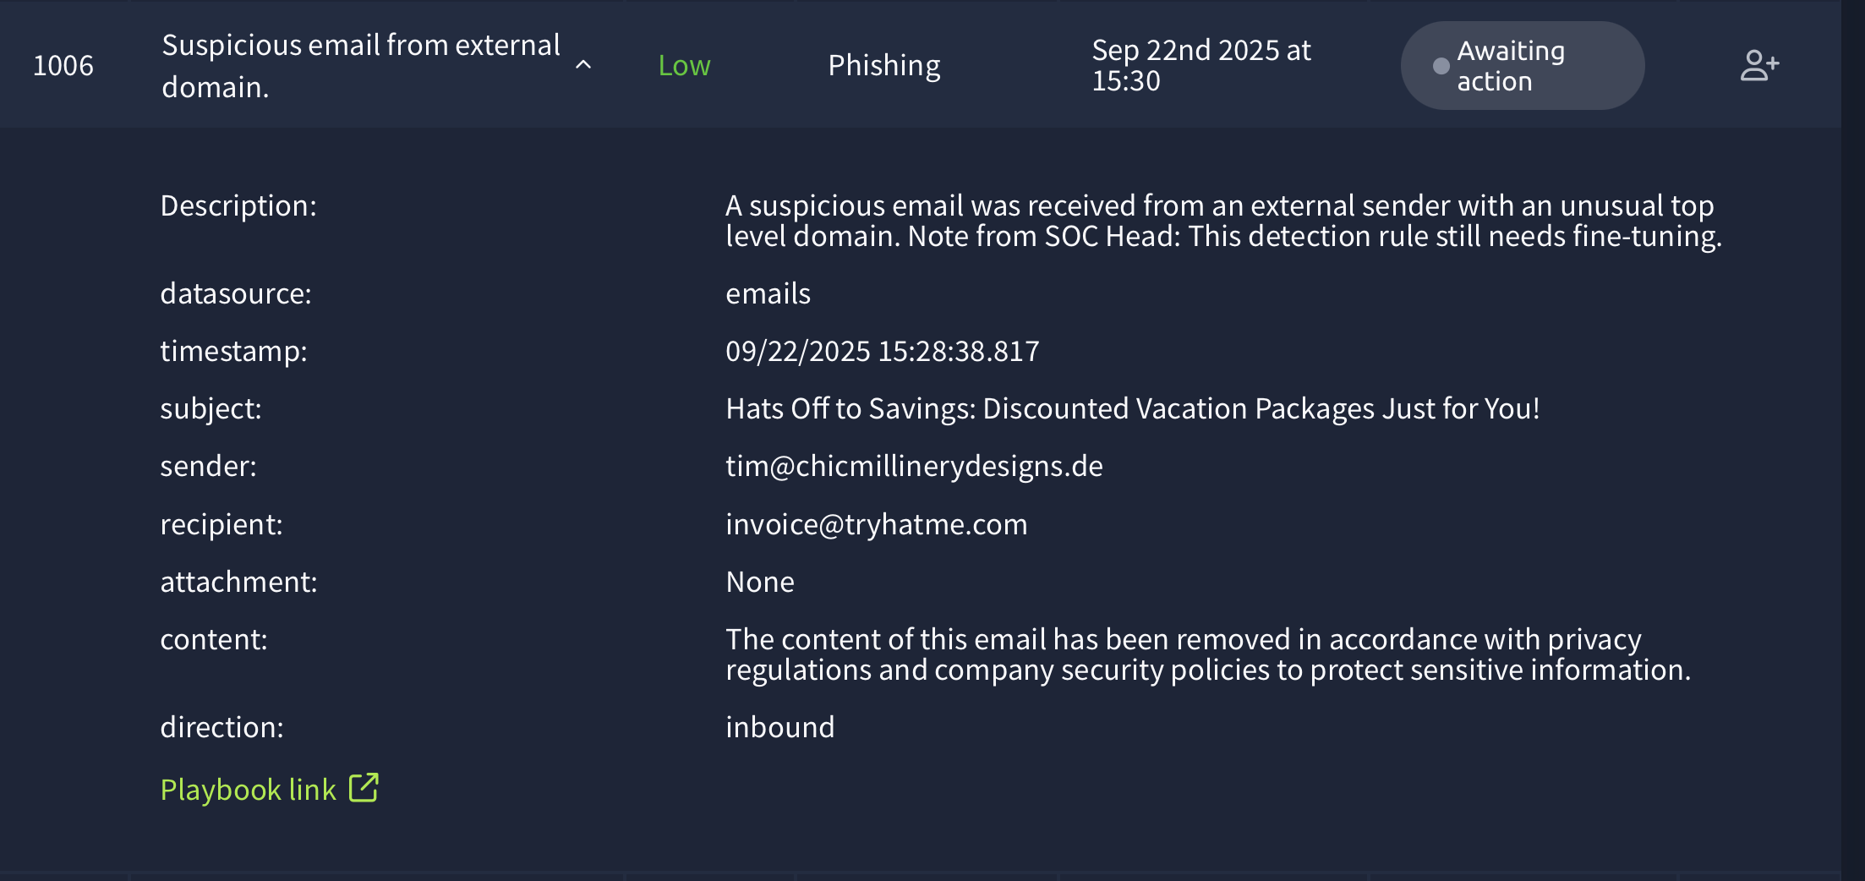

Time of Alert: 09/22/2025 15:26:41.817

**Related Entities:**

Sender: sophie.j@tryhatme.com

Recipient: eileen@gmail.com

**Reason for False Positive:**

* The email appeared to be a phishing attempt
* No attachment
* No further action is required.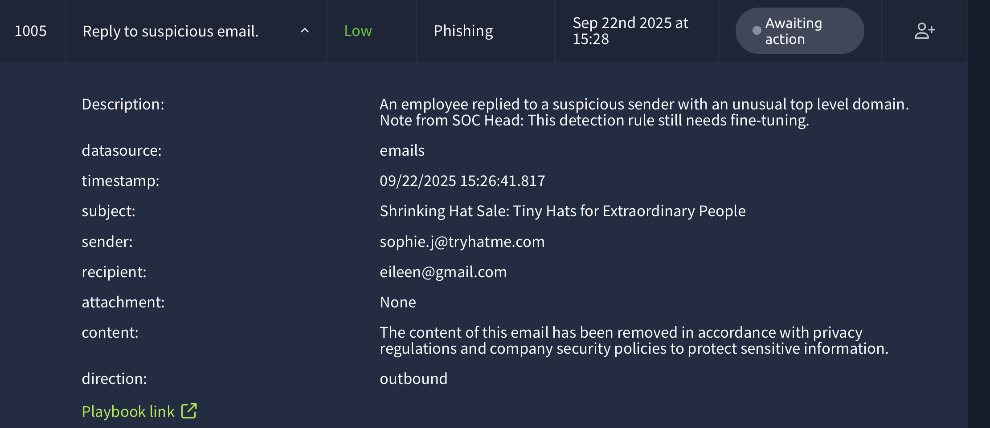

Time of Alert: 09/22/2025 15:13:34.817

**Related Entities:**

Sender: nguyen@styleaccessorieshub.xyz

Recipient: miguel.odonnell@tryhatme.com

**Reason for False Positive:**

* The email appeared to be a phishing attempt
* No attachment
* No further action is required.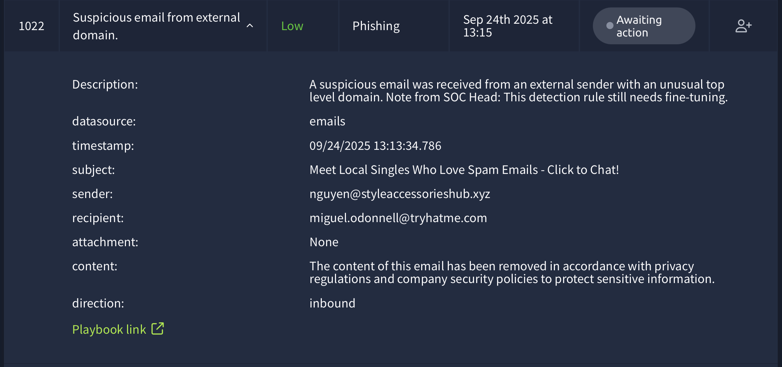

Time of Alert: 09/22/2025 15:27:19.817

**Related Entities:**

Sender: michelle.smith@tryhatme.com

Recipient: molina@headtoppersinc.xyz

**Reason for False Positive:**

* The email appeared to be a phishing attempt
* No attachment
* No further action is required.